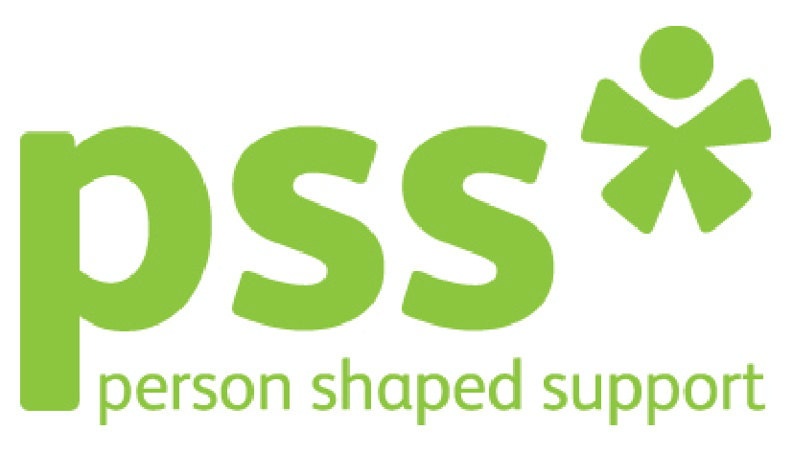
LivPIP Service Plan 2014 - 2015

What are we trying to achieve?

Influence – Improving our reputation locally and nationally so that we have influence on social policy and service development.

What will success look like?
We’ll be the partner of choice. We can back up what we say with hard evidence. Our people are seen as thought leaders. We’re invited to the table on both a local and national level. We get invited to appear in academic articles, speak at conferences and exhibit at events. We will be a leader with PIP UK and our model of delivery will be best practice for other new PIP’s to follow.
What might stop us?
There is a genuine lack of influence from voluntary sector, We have a relatively low profile, Our networking skills are not well developed
How are we going to do this? | Who? | When? | Where are we up to?
*We’ll maximise opportunities to improve our reputation and influence social policy and service development  We will be represented at:  - Local perinatal care pathway meetings  - National PIP UK conference and other National & regional conferences.  - CCG Commissioning Meetings  - PIP UK meetings  We will share best practice within and outside the organisation:  - We will provide LivPIP training to staff from other PSS services  - We will provide training to outside organisations and professionals.  - We will raise awareness of LivPIP through our PSS social media site.  - Use our dedicated website to promote the service/training and bring in new enquiries both locally and nationally, thus raising PSS profile.  - We will keep up to date with developments across PSS so we can promote the whole organisation effectively.  - We will record and share positive case studies with commissioners, Head of Quality JE and head of communications RS  - We will hold an official launch of LivPIP and invite a variety of professionals both locally and nationally.  - Develop and hold a LivPIP steering group | JR  All Staff  JR,MG  JR,MG  All Staff  MG  All Staff  All Staff  All Staff  All Staff JE  All staff  JR MG | Ongoing  Ongoing  Ongoing  Ongoing  Ongoing  Ongoing  Ongoing  Ongoing  Ongoing  Ongoing  Ongoing  By April 2014  Ongoing

What are we trying to achieve?
Growth - Building market share
What will success look like?
Increase in corporate turnover to £16M by 2015, This years target for Merseyside and North is
We focus on selling our current services in our current markets but also take our current services into new markets and develop new services for our current markets.
What might stop us?
- Cuts in public sector spending, Our tender writing skills are under developed, Not a lot of people know who we are and we don’t know who are potential customers are.

How are we going to do this? | Who? | When? | Where are we up to?
- We’ll keep aware of our operating environment:  - Access new LCC and CCG minutes on their websites  - Asking our service users what they see as gaps in service.  - Attending local forums as highlighted above.  - Having a service user on LivPIP steering group  - Keeping up to date with new research.  - Attend PIP UK Meetings and liaise with other national PIP’s  - Identify Key CCG members to work with including Avril Swan, Alison Wright local GP’s. | All Staff  JR, JS  All staff  JR, MG  JR, MG  All Staff  JR MG  JR MG | Ongoing  Ongoing  Ongoing  Ongoing  Ongoing  Ongoing  Ongoing  Ongoing
- We will look out for opportunities for growing and sustaining our service  - Work with PIP UK to develop opportunities for PSS  - Apply for other grant funding opportunities  - We will hold a LivPIP Conference in Liverpool to raise awareness and bring in income.  - Develop and promote LivPIP to local authority  - Work with local Universities to develop research opportunities. | JR,MG  JR  All Staff  JR,MG  All staff | Ongoing  Ongoing  By Feb15  Ongoing  Ongoing
- We will support the implementation of corporate plans to take dementia, PND and short breaks services to the private market  - We will seek to work with PIP UK on training delivery  - We will devise a training package  - We will seek to work with colleges and universities on implementing attachment training to the curriculums | JR,MG  MG  JR | Ongoing  Ongoing  Ongoing

What are we trying to achieve?
Excellence - Delivering person-shaped support services that are value for money, fit for purpose, and delivered with passion.
What will success look like?
Our stakeholders are satisfied and we meet our targets on this. Our services and PSS people are recognised for best practice externally. Our financial ratios add up.
What might stop us?

We don’t consistently capture what people think of us. Approach to performance management is under developed
Need to manage competing stakeholder demands. Not all services are responsive to diverse cultures. Competing demands on resources
Lack of clarity on what efficiency looks like
How are we going to do this? | Who? | When? | Where are we up to?
* We will support the implementation of a new quality assurance framework at a service level | JR,JE | Ongoing
:  - We will support new corporate mechanisms for engaging with our service user groups  - We will work with Jane Evans to engage with Service Users. | JR,MG JE JS  All staff | Ongoing  Ongoing
* We’ll ensure our service is appropriate for our local community  We will review internal data to determine whether services are currently reflecting local demographics and providing services that are accessible to the whole community  - We will put action plans in place where it is identified that services are not doing this  - We will ensure that policies/procedures and publicity documentation are adapted to meet different requirements and be available in different formats e.g. Welsh Language  - LivPIP website available in many different languages  - We will work with interpreters to improve access to different BME groups. | JR MG  All Staff  RS  All Staff | Ongoing  Ongoing  Ongoing  Ongoing
:  - We will support the implementation of the corporate personalisation plan.  - We will review our person centred assessments and amend were necessary.  - We will review internal data capture and provide appropriate services based on geographical areas.  - We will work with Jane Evans on gaining feedback and annual service user survey. | All staff  All staff  JR,JW | Ongoing  Ongoing  Ongoing
* We will support the corporate objective of making PSS a great place to work.  - We will have regular team meetings.  - We will have 6 monthly social outings  - We will liaise with the PND team  - We will have a system of fairness were all staff are given the same opportunities to develop & attend conferences.  - We will have opportunities to attend health events at work such as Yoga and Mindfulness. | All staff  All Staff  All staff  JR,MG  All Staff | Ongoing  Ongoing  Ongoing  Ongoing  Ongoing
* We will develop (or implement if you already have a plan) to maximise volunteering opportunities in our service  - The manager and Clinical lead will be responsible for the recruitment and management of all new volunteers. | JR,MG,JW | Ongoing
* We will promote Dignity in Care

- We will review our service risk register at every Team Meeting | JR | Ongoing
*We will ensure sound financial management within our service  - Ensure budgets come in on target  - Maximise income  - Meet all financial performance targets  - We will discuss financial performance in the context of 1:1s and team meetings  - Get best prices for train fares/hotels/conferences etc  - Send quarterly expenditure reports to CCG and PIP UK | JR  JR  JR  JR  All Staff  JR,JW | Ongoing  Ongoing  Ongoing  Ongoing  Ongoing  Ongoing

