A service evaluation of Little Minds Matter Bradford consultation service: Exploring the influence on professional’s practice

Student ID: 201290738

Commissioned by Dr Matthew Price, Consultant Clinical Psychologist

Contents
Introduction 4
Background 5
Aims 6
Method and methodology 6
Research method 6
Ethics 7
Participants and recruitment 7
Eligibility criteria 7
Inviting participants 7
Consent 8
Data collection 8
Interview schedule 8
Interviews 9
Analysis 9
Results 12
Who took part? 12
What consultation services were used? 13
Thematic analysis results 15
1. More reflective practice 15
2. Improved working and collaboration 16
3. Implementing infant mental health practice 18
4. Reinforced existing knowledge and experience 19
A safe space and secure base 20
Evaluation form statistics 23
Quantitative analysis 23
Discussion 23
Limitations 26
Conclusion and Recommendations 27
References 28
Appendices 30
Appendix 1 – Consultation evaluation forms 30
Appendix 2 – Initial invite email 33
Appendix 3 – Participant information sheet 34
Appendix 4 – Consent form 37
Appendix 5 – Reminder email 38
Appendix 6 – Fully recruited email 39
Appendix 7 – Pre-interview verbal consent script and interview schedule 40
Appendix 8 – Initial coding 1 snapshot– Microsoft Excel 42
Appendix 9 – Snapshot of some of the headings that were printed off and consolidated into fewer themes 43
Appendix 10 – Consolidated themes transferred to Microsoft Excel 44
Appendix 11 – Different tabs created in Microsoft Excel for each development in themes 45
Appendix 12 – Checklist of behaviours to observe in parent-infant interactions 48
Appendix 13 – Self-appraisal form 51

Number of words: 4,982

Introduction
Little Minds Matter (LMM) is a specialist infant mental health service based in Bradford, West Yorkshire. The service was established in March 2018 and was funded by the National Lottery Community Fund. LMM work with practitioners and families to help support them with building better bonds between parents and their babies to help improve the mental health of infants aged between 0 and 2 years.
The service provides training to practitioners, work directly with families, and offer four consultation services. The four consultation services offered are: Reflective groups (practitioners from different services meet once a month to discuss a family that one participant brings to the group); Triage calls (telephone calls practitioners can make to the LMM service to get guidance and advice on how to work with families); Drop-ins (drop-in face-to-face consultation sessions); and Ongoing consultations (ongoing support practitioners can use when working with families).
This report will be focussed on an evaluation of the consultation strand of the LMM service. This evaluation started during the Covid-19 pandemic. The face-to-face consultation services (e.g. reflective group) were being done remotely via online video (Microsoft Teams) during this time. This meant that some practitioners experienced both face-to-face and online consultations, whilst others may only have experienced one or the other.
This report will start by providing some background to why the LMM service is important and the aims of the evaluation. Secondly, the research method used to conduct this evaluation will be explained, followed by the results of the evaluation. Finally, the report will provide a discussion and implications of the evaluation as well as recommendations for the service.

Background
The first two years of a child’s life (from conception to age two years or the 1001 critical days (Leadsom, 2014)) have been identified as being incredibly important for child development and mental health (Hogg, 2019; Leadsom, 2014) for a number of reasons. Stress during pregnancy for example, has been found to increase the risk of cognitive and emotional problems in children (e.g. anxiety, language delays, attentional deficit hyperactivity disorder) (Talge, Neal, & Glover, 2007). Further, parental mental health problems such as depression can result in poor outcomes for infants in later life (Grace, Evindar, & Stewart, 2003). Despite this, there appears to be insufficient services available for children in this age range, with just 27 services designed to support the parent-infant relationship in the United Kingdom (UK) (Hogg, 2019). Child and Adolescent Mental Health Services in the UK are supposed to provide mental health services for children between 0 to 18 years, 42 percent of these services reported that they do not accept referrals for children two years or under (Hogg, 2019). The government and Care Commissioning Groups (CCGs) are recognising the need for such services and more are becoming operational around the UK (Hogg, 2019). This is why services such as LMM Bradford are so important to our communities.
Hogg (2019) state that infant mental health teams are:
‘…expert advisors and champions, driving change across local systems.’ (p.7)
and that they:
‘…can help all the services around a family to do more to support early relationships.’ (p.7).
Babies are dependent on parents for their brain development because whilst most neurons are present at birth, they only start to become functional in their interactions with caregivers via sensitive and responsive parenting (Balbernie, 2001; Trevarthen & Aitken, 2001). Infant mental health teams aim to increase the attachment between parent and infant because it is this bond (secure attachment) that not only contributes to normal brain development, but also allows children feel safe to explore the world knowing that their caregiver will be available when they need them (Ainsworth, 1979; Bowlby, 1969, 1988, 2005). If the world appears more unsafe (as a result of them not feeling they have a place of safety (e.g. caregiver)), this makes children more vulnerable to developing mental health problems in the future (Mikulincer & Shaver, 2012).

Aims
Service evaluations are conducted to check the performance of a service and its effectiveness (Price, Latchford, & Hughes, 2019). To support further funding and thus the continuation of the service, an evaluation of the consultation services LMM Bradford provide was conducted. The aim of the evaluation was to answer the following research question:
Do infant mental health practitioner consultations influence practice?

Method and methodology

Research method

Qualitative research methods use words as data (rather than numbers as in quantitative research), and the data is analysed by looking for patterns in the data (Braun & Clarke, 2013). Thematic analysis is a qualitative research method used for gathering in-depth qualitative data. Researchers look for themes (patterns) in the data, analyse these themes and report on them (Braun & Clarke, 2006, 2013). It is a flexible method that can be applied to a range of research questions (Braun & Clarke, 2013). In order to obtain practitioner’s views on how the LMM consultations changed their practice, thematic analysis was chosen as the primary research method for this evaluation. This is because this method allowed for in-depth data to be collected related to practitioner’s experiences of using the consultations, and whether or not they changed their practice.
Whilst the routine collected data by LMM (feedback forms given to practitioners after they have had their consultation (Appendix 1) is very valuable and a convenient way to obtain immediate feedback to the service, the questions on the feedback forms are specific to certain areas (e.g. ‘Do you feel more confident to work effectively with
difficulties within the parent-infant relationship with families?’). This type of questioning, whilst useful in getting specific feedback in certain areas for the service, could result in valuable information being missed. Thematic analysis allows for more open questions to be asked and the generation of more detail on what practitioners got out of the consultation service. The feedback forms are given to practitioners straight after the consultations, so practitioners would not yet have put into practice guidance received from the consultations. Conducting qualitative interviews with practitioners at a later date allows practitioners to talk about how they have put suggestions into practice rather than getting their views on what they think they will put into practice, allowing the research question to be answered. Some routinely collected data will be used to supplement the primary thematic analysis, however.

Ethics

Ethical approval to conduct this study was obtained from the University of Leeds DClinPsy course research ethics committee (Ref: DClinREC 19-005).

Participants and recruitment

Eligibility criteria

Any practitioner who had used one or more of the LMM Bradford consultation services could take part in this evaluation.

Inviting participants

An email (Appendix 2) was sent to practitioners who used one or more of the consultation offerings inviting them to take part in this evaluation. The email was sent by the commissioner along with the participant information sheet (Appendix 3) and consent form (Appendix 4), and copying in the evaluator (Trainee Clinical Psychologist) asking practitioners to email the evaluator if they would like to take part in the
evaluation. Emails were initially sent in batches of 20 due to the large number of practitioners who had used the service. Practitioners were selected at random to ensure there was a diverse mix of practitioners, date they used the consultation service and consultation type. A reminder email was sent one to two weeks later (Appendix 5). If an insufficient number of practitioners were recruited, then another batch of 20 were sent out a week after the reminder email is sent. The batch size was increased (e.g. from 20 to 30) where insufficient responses were received from the previous batch or decreased where (e.g. from 20 to 10) where only a small number of participants were needed. An email was created to send to practitioners who expressed an interest in the study after the study was fully recruited (Appendix 6), but this did not need to be used.

Consent

Verbal consent was taken from practitioners over the telephone prior to the interview by reading each statement of the consent form to the participant and asking them to state ‘I agree’ after each statement. The practitioner was asked to say their name in full and the evaluator verbally stated the date. Verbal consent was audio recorded using a Dictaphone and an Olympus TP-8 Telephone Pick-Up Microphone as a record of consent. Prior to gaining verbal consent, a pre-interview verbal script was read out to the participant (Appendix 7).

Data collection

Interview schedule

Braun and Clarke (2013) state that asking open questions is most important for effective qualitative interviews. An interview schedule (Appendix 7) was developed by the commissioner and the evaluator. It started with four brief opening questions to gain the context of use of the consultation service(s), four main questions (predominantly open questions in line with the guidance from Braun and Clarke (2013), with some closed questions to narrow down responses, which would then be built on with open questions) about the usefulness of the consultations, and two very open questions to give the participant the opportunity to discuss things not asked and to ask any questions.

Interviews

The original research design aimed to primarily conduct qualitative interviews via telephone because it was recognised that practitioners would be busy working Monday to Friday (when the interviews would be done) and this allowed more flexibility and convenience for them. There was also the option of meeting face-to-face should practitioners prefer this option. Only telephone interviews were offered however, because recruitment took place during the lockdown phase of Covid-19.
Brief (10-15 minutes) one-to-one telephone interviews were conducted with practitioners. Interviews were recorded using a Dictaphone and Olympus TP-8 Pick-up Microphone and transcribed verbatim. To reduce bias in the findings, participants were advised prior to the interview (in the invitation email) that the evaluator was not part of the LMM service and works independently from them. Participants were reminded of this again immediately before the interview as part of the verbal script (Appendix 7). It was hoped that this would allow practitioners to be more open and honest in the interviews.

Analysis

Interview data was analysed using thematic analysis. It has been identified that one of the flaws of qualitative analysis is that some researchers do not provide sufficient detail on the process of analysis (Attride-Stirling, 2001; Braun & Clarke, 2006). Other researchers talk about how ‘logical, traceable, and clearly documented’ (Tobin & Begley, 2004, p.3) processes enhance the dependability of thematic analysis (Nowell, Norris, White, & Moules, 2017; Tobin & Begley, 2004). An audit trail of all decisions made is also noted to be good practice in relation to increasing trustworthiness of the results (Nowell et al., 2017). Braun and Clarke (2006) suggest six phases of thematic analysis (see Table 1. below). They advise that all phases do not have to be followed as they are not rules, but rather guidelines that should be used flexibly dependent on the research question and data (Braun & Clarke, 2006). Braun and Clarke (2006) also advise that this is not a linear process and researchers can go back and forth between phases. This guidance was followed when analysing the data in this evaluation. Table 2 shows the phases of thematic analysis with specific information of how it was applied to this evaluation to make clear the process of analysis. As Braun and Clarke (2006) state, this was not a linear process and there were times when the evaluator went back and forth. This happened most frequently between phases 3, 4 and 5.
Table 1. Phases of thematic analysis
Phase | Description of the process
1. Familiarizing yourself with your data: | Transcribing data (if necessary), reading and re-reading the data, noting down initial ideas.
2. Generating initial codes: | Coding interesting features of the data in a systematic fashion across the entire data set, collating data relevant to each code.
3. Searching for themes: | Collating codes into potential themes, gathering all data relevant to each potential theme.
4. Reviewing themes | Checking if the themes work in relation to the coded extracts (Level 1) and the entire data set (Level 2), generating a thematic ‘map’ of the analysis.
5. Defining and naming themes: | Ongoing analysis to refine the specifics of each theme, and the overall story the analysis tells, generating clear definitions and names for each theme.
6. Producing the report: | The final opportunity for analysis. Selection of vivid, compelling extract examples, final analysis of selected extracts, relating back of the analysis to the research question and literature, producing a scholarly report of the analysis.
Table extracted from Braun and Clarke (2006), p.87

Table 2. Phases of thematic analysis for LMM SEP evaluation
Phase | Description of the process
1. Familiarisation with data: | Interview transcribed. Transcribed interviews printed and read and re-read. Initial ideas noted on hard copies of individual interviews.
2. Generating initial codes: | Microsoft Excel used to record relevant elements of data related to the research question. Headings (columns) were created using data extracted from the transcripts and data for each participant (each participant had their own row(s) to record data extracts) recorded by either creating a new column for a new idea or entering their data under an existing column (Appendix 8).
3. Searching for themes: | The number of times an idea/potential themes was talked about was reviewed and headings with the highest frequency highlighted in green. Ideas raised at a moderate frequency were highlighted in a lighter green, and those mentioned infrequently left white. All headings (with their respective colours) were printed off and consolidated into fewer themes (Appendix 9).
4. Reviewing themes: | Consolidated themes were transferred to a new tab in Microsoft Excel with the new themes in columns, and the ideas and/or previous themes/headings that make up this theme underneath (Appendix 10). For each subsequent amendment to the themes, a new tab was created to allow the evaluator to keep a record of how themes emerged (audit trail) (Appendix 11).
5. Defining and naming themes: | As part of this process, the evaluator sent suggested themes along with the data that made them up to the commissioner for checking and feedback. Any suggestions for changes were discussed and incorporated into the developing themes on agreement between the two parties. Descriptions of the themes were added to the themes as they became more refined (Appendix 11).
6. Producing the report: | Themes related to answering the research question presented in a report, explaining what the theme is, how it relates to the research question, and including quotations relevant to themes to validate their existence. Any final analysis and tweaks to themes made.
Braun and Clarke (2006) Six phases of thematic analysis adapted specific for this evaluation

Routinely collected quantitative data from the evaluation forms was analysed using Microsoft Excel.

Results

Who took part?

Ten participants from various health or social care professions were interviewed between 19 May 2020 and 2 July 2020. Braun and Clarke (2013) suggest a sample size of 6 to 10 interviews for small thematic analysis projects (p.50). As this service evaluation was considered a small research project, 10 practitioners taking part was considered sufficient. Those interviewed had used one or more of the consultation offerings. All participants were female. Figure 1. below shows the different practitioners who took part in this evaluation. Health Visitors were the most represented group with the other practitioners having the same number of people take part.

Figure 1. Practitioners who took part in the interviews

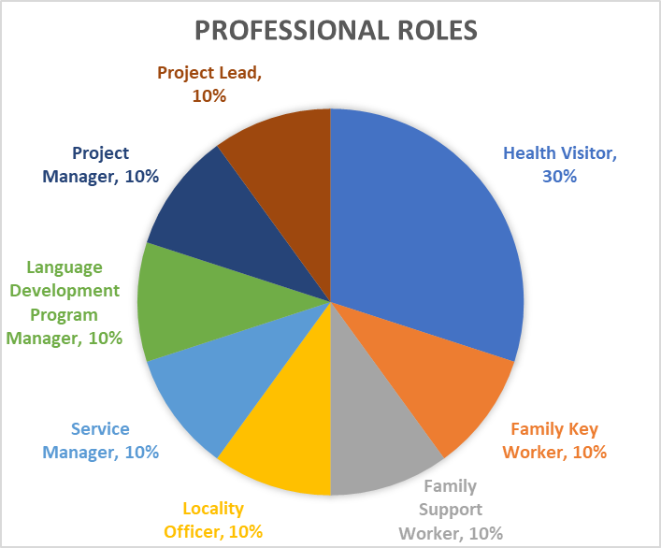

What consultation services were used?

Practitioners reported to use one or more of the consultation services. The most used consultation service was the reflective groups, followed by triage calls, with drop-ins and ongoing consultations being used in equal amounts. Figure 2 shows the percentage use of each consultation, and Table 3 provides more details on consultation use by practitioners (e.g. consultations used, frequency, last time used).

Figure 2. Consultation services used by practitioners

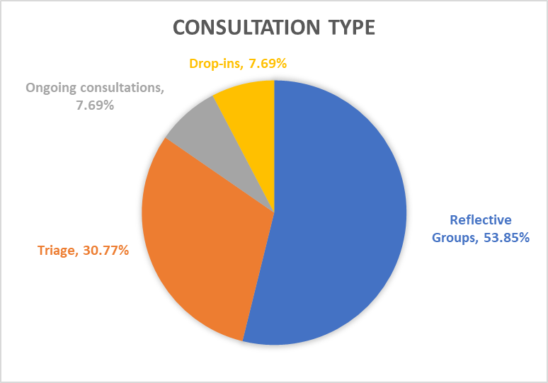
NB. Some practitioners used more than one consultation service

Table 3. Consultation use for each professional
Participant ID | Interview Date | No. of consultation services used | Consultations used | Frequency of use | No. Times consultations accessed (Approx.) | First time accessed | Last time accessed
P01 | 19/05/2020 | 2 | Reflective Group*  Triage | Once a month* | 4 to 5* | 7-months ago* | 2-3 weeks ago*
P02 | 20/05/2020 | 1 | Drop-in | Once only | 1 | 18-months ago | 18-months ago
P03 | 26/05/2020 | 2 | Reflective Group*  Triage | - | 5 (Reflective Group)  4 (Triage) | 6-months ago (Reflective Group)  21-months ago (Triage) | 2-weeks ago (Reflective Group)  2.5-months ago (Triage)
P04 | 18/06/2020 | 1 | Reflective Group | Once a month | 12 | 12-months ago | < 1-month
P05 | 22/06/2020 | 2 | Reflective Group*  Triage | Once a month* | 12 (Reflective Group)  3-4 (Triage) | > 12-months ago | 1-month ago (Reflective Group)  1-week ago (Triage)
P06 | 22/06/2020 | 1 | Ongoing Consultation | - | - | 24-months ago | 1 to 2-weeks ago
P07 | 23/06/2020 | 1 | Triage | Once only | 1 | Few months ago | Few months ago
P08 | 02/07/2020 | 1 | Reflective Group | Once a month | 12 | 12-months ago | 2-weeks ago
P09 | 25/06/2020 | 1 | Reflective Group | Once a month | 3 to 4 | 24-months ago | 2-weeks ago
P10 | 02/07/2020 | 1 | Reflective Group | Once a month | 12 | > 12-months ago | 2-weeks ago
Key: * = Most frequently accessed service; - = No data

Thematic analysis results

In terms of whether or not the LMM consultations changed practitioner’s practice, four main themes were identified: 1. More reflective practice; 2. Improved working and collaboration; 3. Implementing infant mental health practice; and 4. Reinforced existing knowledge and experience. These main themes and associated sub-themes (where relevant) are discussed in more detail below.

1. More reflective practice

There was a strong focus on an increase in reflective practice following the consultations. This was particularly relevant for the reflective group. Two sub-themes were identified under this theme; Seeing the things from different perspectives and General practice.

1.1. Seeing the things from different perspectives

Practitioners talked about how using the consultations allowed them to view working with parents and infants from different perspective’s (e.g. from the perspective of the parent or child).

‘…using that space to reflect as well on what you’ve heard and what you can reflect on kind of thinking outside of the box you know more of the sort empathy side of things and how women might be feeling and what they’re saying and thinking.’ (P08, p. 2)

‘I think it’s enabled you to explore lots of different factors that were affecting the family…’ (P06, p.1)

1.2. General practice

This sub-theme relates to how practitioners were more reflective in their general practice. Practitioners talked about how they increased reflection in supervision, when working with families and in general practice (e.g. generally being more thoughtful and reflective in their work). This also included reflecting on their own role when working with families.

‘I think it keeps me focussed on reflective supervision rather than tick box supervision.’ (P09, p.2)

‘It's helped me to really focus on what I want to achieve and what the family want to achieve from our contact and just be a bit more focused about the support that we're giving.’ (P05, p.2)

2. Improved working and collaboration

Practitioners talked about how they felt they improved the ways they worked with others following the consultations. This theme had two sub-themes; Improved working with families, and Improved team working.

2.1. Improved working with families

Practitioners talked about how they felt they have been working more collaboratively and positively with families. Being more proactive in their work with families (e.g. referring earlier) was also something practitioners changed in the way that they worked with families.

‘I think the key points are to work alongside the family and kind of let them lead if you like. To try and share you know pick out the positives in what's happening in that situation. To give time to things and build trust with families to kind of build that strong relationship with families that’s really important to not kind of think like we’ve got 6-weeks to do this because things don’t happen like that.’ (P04, p.1-2)

‘…so during Covid we’ve felt that we’ve had more referrals for women in early pregnancy, so what we’ve tried to do is gather as much information as we can and sort of perhaps refer them a bit earlier on, have families on projects radars…’ (P08, p.4)

2.2. Improved team working

This sub-theme relates to how practitioners felt that they valued working with other services and LMM practitioners (particularly relevant to the reflective groups). Practitioners talked about how since the consultations they have started to work more with other practitioners involved with the same families, learn from each other, and have built stronger relationships with others within their own teams following the consultations.

‘I think they for me I think they strengthen the relationship between the team members in the project.’ (P03, p.2)

‘…we have tapped into the consultations as a joint venture with Baby Steps, which is another Better Start project, so collectively we decided to do consultations together I suppose for a number of reasons: 1) Because the teams are quite small; 2) There’s quite often we’re supporting the same family or the same woman, so it kind of makes sense to kind of have those joint conversations…’ (P08, p.1)

3. Implementing infant mental health practice

This theme relates to how practitioners implemented infant mental health knowledge into their practice. It has two subthemes; Using suggested resources, and Increased focus on infant mental health.

3.1. Using Suggested resources

Practitioners talked about how they used resources suggested by LMM in consultations. This included the checklist of behaviours (Appendix 12) to observe parent-infant interactions and use of genograms (family trees).

‘It tends to be more the way I would work with the team, so if we get a case now that comes into our triage process and if we’re not sure about whether we should accept the case, we can go through the check list and think right well the Little Minds Matter check-list and think right well these things are happening in this case so it looks like it’s one for us with the potential for involvement from some other services or it’s just one for us. So that’s quite useful.’ (P04, p. 2)

3.2. Increased focus on infant mental health

This sub-theme involves advocating infant mental health by talking to other practitioners about it as well as families. Practitioners also talked about how they focus more on infant mental health by focussing more on the infant and the parent-infant relationship when working with families. It was clear from the interviews that practitioners switched their focus more to the infant in their interactions with families than they had previously.

‘…more infant mental health really gets pushed down the list of priorities when we talk about that 1001 days and sometimes you feel like you’re battling other agencies, yes I understand that practicalities are important, but once these 1001 days are gone that time has gone, so it’s being the advocate and the voice and saying actually no, you know this is a priority and it’s just having that other relationship with a practitioner who is from that same view and that will support me.’ (P01, p.3)

4. Reinforced existing knowledge and experience

Practitioners talked about how the consultations strengthened their existing knowledge about infant mental health, reminding them of what they already knew or had learnt from past training and their experience of working with families.

‘…the consultation sort of helps remind and solidify practices not just from the Little Minds Matter training, but you know my practitioner and experiential knowledge related to working with families.’ (P03, p.2-3)

Practitioners talked about how consultations were reassuring (e.g. that the concerns they had about a family were justified) and increased confidence in their work.

‘…there’s always kind of like a check-list that goes alongside the consultation and it was really helpful to see that check-list because it kind of reassured us affirmed that actually some of the things that we’re doing through our triaging processes and our risk assessments that we’re doing similar things, so if anything it reaffirmed that actually we’re on the right pathways…’ (p08, p.3)

‘…I just think it’s useful for really upskilling staff and making sure that when they go out they’re confident about ensuring that the child’s voice is kind of heard.’ (p04, p.2)

Some practitioners advised they did not feel that the consultations had changed their practice, but instead had reinforced existing knowledge. However, there was some ambivalence around this as practitioners also talked about instances where their practice had changed in the same interview.

‘…so it didn’t change my practice, but it was sort of informing how I was seeing things and observing things. So it’s reinforcing that solidifying. It will have changed what I’ve done at some point, but I just can’t get my head to reach that right now.’ (P03, p.3)

This theme linked to all the other themes in that it appeared to help practitioners build on existing knowledge in those areas (i.e. reflective practice, improved working and collaboration, and implementing infant mental health practice).

'I don't think it's changed my practise enormously in terms of a whole new concept for me I think it's something that I was already doing, but not as thoughtfully or as reflectively.' (P05, p.4)

Themes one to three also stood alone in that new knowledge was also gained in these areas. Themes one to three also link with one another. For example, reflecting on a family can improve working and collaboration with families and between practitioners.

‘Just learning from each other really you know using that kind of reflective method to kind of talk through cases.’ (P08, p.5)

The themes and the connections between them are illustrated in Figure 3 below.

A safe space and secure base

Whilst this is not directly related to answering the research question and therefore not a theme, there was a strong sense across the interviews that the LMM consultations offered a safe space and secure base where practitioners felt they could talk openly about the families they were working with, and obtain support with families when they needed it. This support was not only from LMM, but also practitioners from other projects and within projects.

‘…I felt I knew that I could ring Little Minds Matter and I could talk about what my thoughts and feelings were about the lady what my worries were, and it was a safe space to do so and I knew because of Little Minds Matter the work that they do that they would understand my thought process and it was fantastic they supported me…’ (P01, p.2)

Whilst this was not a theme, it appeared to be linked to the themes in that it underpinned them.

Evaluation form statistics

Quantitative analysis

Table 4 below includes means, ranges and percentage of responses per score for each consultation evaluation form. The sample size for each question is included in the table. The results from Table 4 will be discussed further in the discussion section and their relationship to the themes identified in the qualitative analysis explored.

Discussion

Four main themes were identified from the thematic analysis: Reinforced existing knowledge and experience; More reflective practice; Improved working and collaboration; and Implementing infant mental health practice. The themes were found to be interlinked with the overarching theme being reinforcing existing knowledge and experience. However, the three other themes were also found to be independent from the overarching theme as new knowledge was also gained from the consultations that practitioners put into practice. There was a strong sense of the LMM being a safe space to talk and reflect about families as well as being a secure base from which practitioners can work with each other and families. This appears to mirror the secure parent-infant attachment described by scholars (Ainsworth, 1979; Bowlby, 1988, 2005). It is possible that this contributed to practitioner’s confidence when implementing infant mental health practice, reflecting on families and working more collaboratively because LMM not only provided a safe space to do this, but practitioners also felt that they could turn to LMM when they needed support. Norburn (2017) in their service evaluation of an infant mental health consultation service for social workers in Leeds, found a similar theme which they called ‘feeling safe’ (p.12). Perhaps the knowledge infant mental health teams have of attachment theory results in them embodying this knowledge and practicing the positive behaviours associated with this model of working. Norburn (2017) suggested that if social workers could model the safe base for parents, this could help them to make better decisions about families. It is possible that practitioners in the current evaluation could also model the secure base they are trying to get the parents to become for their infant

and that the LMM consultations can help them do this. Further, this could help parents model this behaviour and become better able to respond sensitively to their child’s needs.
As the reflective group was the most frequently used service by the participants of the qualitative interviews, it could be argued that it is not surprising that improved reflective practice was one of the outcomes of the qualitative analysis. A similar argument could be made about the implementation of infant mental health practice with the LMM being an infant mental health service. However, it is important to acknowledge that the presence of this theme in itself suggests that the reflective group and the service is doing what it intends to do (provide a space to reflect and improve practitioner’s knowledge and practice in infant mental health). It also indicates that LMM consultations are effective in equipping practitioners with reflective skills and infant mental health knowledge that they can and do use in practice.
Quantitative analyses conducted using data obtained on the day of the consultations with a larger sample of practitioners than the qualitative study, showed that most of them felt that their understanding of working with parent-infant relationships had improved, that they felt more confident working with the difficulties in the parent-infant relationship, and they felt that the consultations would be very useful to their role. The thematic analysis results illustrate that not only did practitioners go onto put the knowledge they had gained into practice (e.g. implementing infant mental health practice, which could be linked to their reported improved understanding of working with parent-infant relationships), but that the confidence they gained from the consultations remained with them after the consultations when they went onto work with families. This suggests that the evaluation forms provide a good indication of the usefulness of the consultations in actual practice.
The qualitative and quantitative results demonstrate that the LMM consultations are driving change in practitioners in terms of their practice helping them to support families improve the parent infant relationships. This fits with the definition of infant mental health teams provided by Hogg (2019) (as mentioned in the background section) suggesting that LMM Bradford are performing in line with expectations of an infant mental health service.
Thematic analysis found that generally the LMM consultations influenced practitioner’s practice either by reinforcing existing knowledge and/or providing new knowledge. However, on occasion there appeared to be some ambivalence related to whether or not practitioners felt that the consultations changed their practice. This tended to be dependent on how the question was asked. When directly asked if the consultation changed their practice, some practitioners tended to say they did not think it did or appeared more hesitant. However, when the question was reframed by asking practitioners if they did anything different when working with families after the consultations, they would then discuss this question more openly and tended to come up with ways in which their practice had changed. It is possible that practitioners felt uneasy stating their practice had changed, perhaps because they feel that they are health and social care professionals who should already know some of this and be practicing this anyway. The use of language (i.e. the word ‘practice’) could feel too professional like the evaluator could be suggesting that their practice was not sufficient to begin with. It was therefore important when conducting this evaluation to have had an alternative way of asking this question to ensure sufficient data was gained to answer the research question.

Limitations

It is possible that for some practitioners, the amount of time between the consultation and the interview could have affected their memory on what they got out of the consultations. This could mean some information may have been missed and not included in the evaluation. However, to help get more information and help practitioners talk in more detail about their experiences, they were asked to provide specific examples. Further, from the data gained from the interviews, it appears that most practitioners were able to talk about how LMM consultations influenced their practice and valuable insights were gained from the interviews.
The evaluator checked the themes with the commissioner of the project as a quality check of the themes. However, it is important to acknowledge that as the commissioner of the project it is possible that they may lean towards themes that show the service in a positive light, particularly as the evaluation would be used help secure further funding for the service. The fact that the evaluator was external to the LMM service meant that they were more impartial, and the transparency of the process of analysis (Table 2) also helps to increase the trustworthiness of the results (Braun & Clarke, 2006; Nowell et al., 2017).

Conclusion and Recommendations

This service evaluation of the LMM consultation services found that the service did influence practice in terms of increasing reflective practice, improved collaborative working with teams and families, implementation of infant mental health practice, and reinforcing existing knowledge and experience. It also found that the evaluation forms give a good indication of how practitioners will implement the knowledge and skills from the consultations into their practice when working with families. The interviews give a sense of LMM consultations being a safe space to talk about difficulties in the parent-infant relationships, suggesting the service is modelling the relationship that their service aims to build between parent and infant and this could link to the confidence practitioners feel when working with families after the consultations.
LMM should continue to offer the consultation services particularly the reflective groups and triage calls as these were the most used services. Whilst ongoing consultations and drop-ins have lower numbers, the feedback from these services was just as positive and similar themes were found. Perhaps an exploration of why these services are not used as frequently could be conducted by LMM to see if there are any barriers to using these services.

References

Appendices

Appendix 1 – Consultation evaluation forms

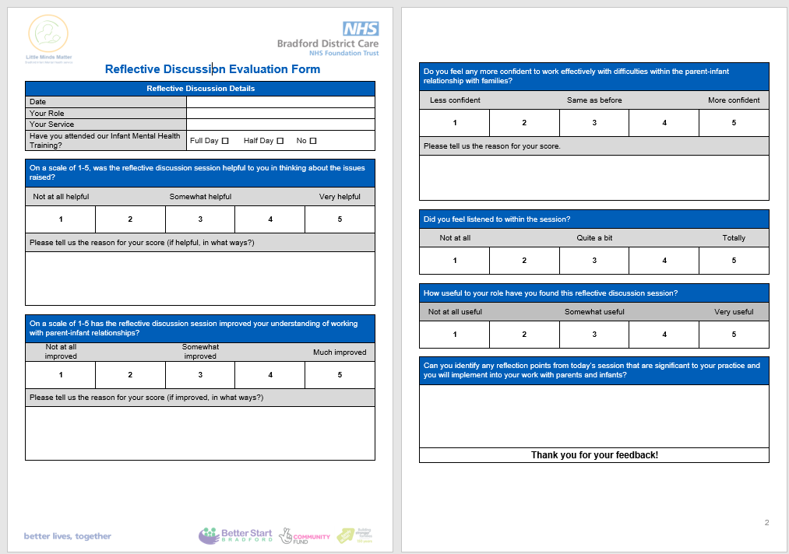

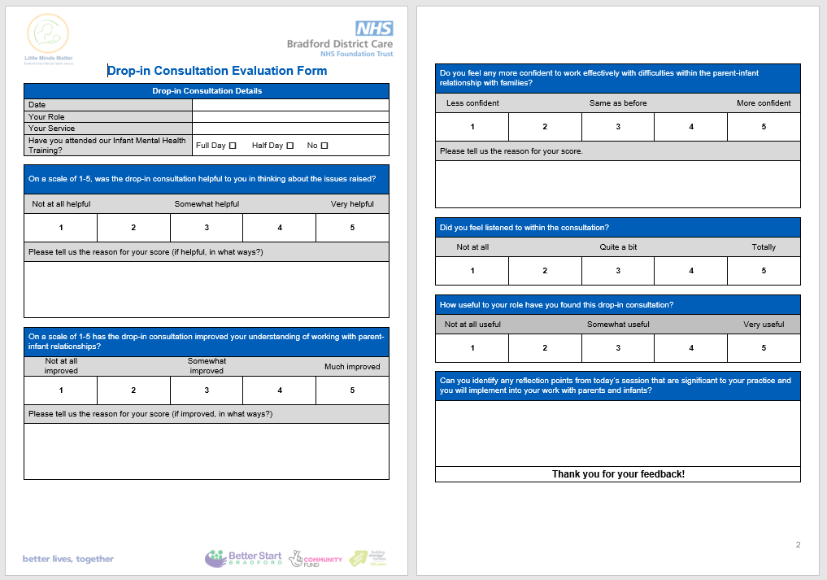
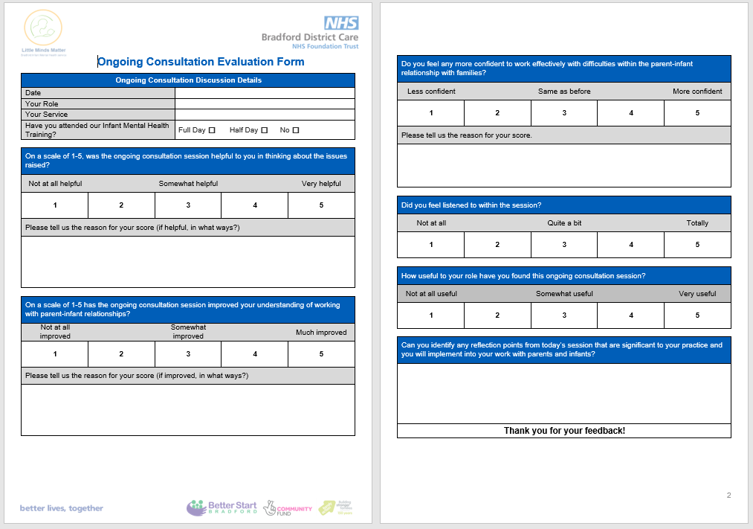

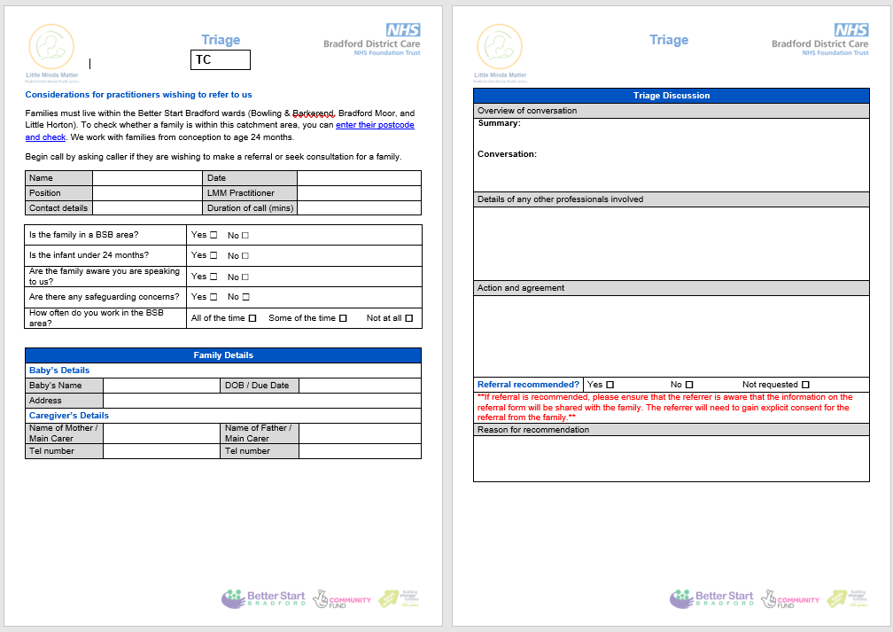
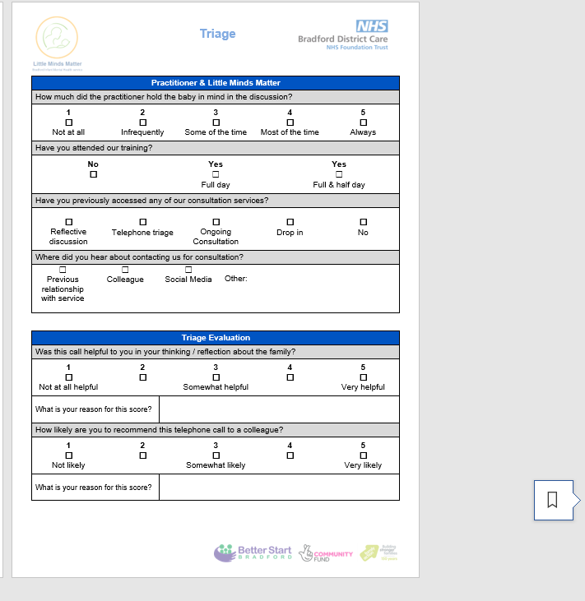

Appendix 2 – Initial invite email

Email 1: Email to professionals regarding telephone interview

Subject: Invitation to provide feedback about Little Minds Matter professional consultations

Dear colleague,

You are being contacted because you used our Little Minds Matter consultation service. We hope that you found it beneficial.

As you know, your feedback is extremely important to us. We would like to invite you to speak with [NAME OF EVALUATOR] (Psychologist in Clinical Training), who is independent from the team, to share your feedback on whether our consultations have influenced your practice. This will be a brief interview (10-15 minutes) conducted over the telephone at a time that best suits you. All feedback will be anonymised and will help us to shape the future consultation services we offer.

Please find attached a participant information sheet, which provides more information about the interviews. A consent form is also attached for your information as well as the University Research Participant Privacy Notice, which explains how we use your personal data (e.g. email address, phone number).

If you would like to know more information or participate, please contact [NAME OF EVALUATOR] via email: [EMAIL ADDRESS OF EVALUATOR].

Thank you for your time. We look forward to hearing from you.

Best wishes,

The Little Minds Matter team

Appendix 3 – Participant information sheet

Participant Information Sheet

The title of the service evaluation project
Do consultations help professionals recognise that ‘little minds matter’?

Invite to participate
You are being invited to participate in a service evaluation project for the Little Minds Matter: Bradford Infant Mental Health Service.

Before you decide whether to take part in providing verbal feedback to inform the evaluation, it is important for you to understand why the evaluation is being conducted and what your participation will involve. Please take time to read the following information carefully. You are welcome to ask further questions if you wish. Take time to decide whether or not you wish to take part.

What is the purpose of the project?
The purpose of this service evaluation project is to evaluate the consultations provided by the Little Minds Matter service. The results of the evaluation may be used by the service to discuss the work they do with external organisations. This evaluation will also support the continuous improvement of the consultation offer.

You are invited to participate in a semi-structured telephone interview. This interview will take up to 15 minutes and will involve a discussion regarding whether your clinical practice has changed after using the Little Minds Matter consultation service.

Recording of interviews
To ensure that the analysis and findings are accurate and of a high quality, it is necessary to audio record your telephone interview. Audio recordings will be transferred to an encrypted University drive following your interview and then deleted from the audio recording device.

The audio recordings of our telephone interview will be used only for analysis. No other use will be made of them and no one outside the project will be allowed access to the original recordings. They will be deleted from the secure University drive immediately following transcription of the data.

Why have I been chosen?
All practitioners who used the Little Minds Matter consultation service and signed up to their mailing list have been invited to participate in this evaluation.

Do I have to take part?
It is entirely up to you whether to take part in this evaluation project. If you do decide to take part, you will be given this information sheet to keep, and verbal consent will be taken from you over the telephone (where a face-to-face interview is conducted you will be asked to sign a consent form instead). You will be sent the consent form via email (with this information sheet). If you decide to take part, the interviewer will go through the consent form with you over the phone before the interview starts and will electronically sign it on your behalf.

You can withdraw up to a week following your interview. Withdrawing will not impact on any future support you may seek from the Little Minds Matter service.

What do I have to do?
You will be asked to participate in one telephone interview, which will take up to 15 minutes. You will be asked you to draw on your experiences of using the Little Minds Matter consultation service and whether this has influenced your clinical practice.

What are the possible disadvantages and risks of taking part?

The nature of the clinical work in infant mental health is potentially distressing, therefore there is a risk that the interview may trigger distress when reflecting on your experience.

If this occurs, it may be appropriate to signpost you to consult with the Little Minds Matter team or seek clinical supervision within your service. Please note, it will be your responsibility to co-ordinate this.

What are the possible benefits of taking part?
There are no immediate benefits for those participating in the project. However, this evaluation will help the service to better understand the value of its consultation service and how this might be improved for future.

Use, dissemination and storage of evaluation data
Findings from the project will be:

- included in the 2019-2020 Little Minds Matter Annual Report
- shared with commissioners and senior stakeholders within Bradford District Care NHS Foundation Trust and Better Start Bradford
- shared as a poster at a Better Start Bradford “Knowledge Café”
- shared as a poster at the University of Leeds Service Evaluation Project Poster Conference.

It is also hoped that the project will be published in a journal article. Participants will not be identifiable when disseminating the research via any of the above mediums.

What will happen to my personal information?
The transcripts will be anonymised and only identifiable by an identification number. The data will be stored on a private university computer drive and will be deleted either 2 years after publication or 3 years after data collection, whichever is longer.

There are limits to anonymity:

- as the evaluation involves using qualitative data (i.e. conversations) anonymised quotations will be used, from which you may be able to identify comments that you made during our interview. However, as identifiable details would have been removed, no-one else can identify you from them.
- it is our duty of care to inform appropriate services if you disclose that you or others are at risk of harm. Any necessary steps for safeguarding purposes will remain your responsibility.

For further information about the University’s use of personal data, please see: https://dataprotection.leeds.ac.uk/wp-content/uploads/sites/48/2019/02/Research-Privacy-Notice.pdf. A copy of this University Research Participant Privacy Notice guidance has also been sent to you via email with this participant information sheet.

What will happen to the results of the evaluation project?
All the contact information that we collect about you during the evaluation will be kept strictly confidential and will be stored separately from the data collected through your telephone interview.
As mentioned previously, the results will be disseminated through several means, and likely be published. As a participant, you will not be identified in any report or publication.
Given the importance of the evaluation data, the findings from the project may be used for additional research.

Who is organising / funding the evaluation?
The evaluation will be conducted on behalf of the Little Minds Matter: Bradford Infant Mental Health Service. The interviewer will be [NAME OF EVALUATOR], Psychologist in Clinical Training. [NAME OF EVALUATOR] is independent of the Little Minds Matter service, and is completing this Service Evaluation Project as part of the Doctorate in Clinical Psychology training programme at the University of Leeds.

Who has reviewed the study?
The research has been considered and approved by the Doctorate in Clinical Psychology Research Ethics Committee at the University of Leeds (Application reference: DClinREC 19-005).

Contact for further information
[NAME OF EVALUATOR], Psychologist in Clinical Training at the University of Leeds will be conducting the Service Evaluation Project and facilitating the telephone interviews. [NAME OF EVALUATOR] is contactable via email on: [EMAIL ADDRESS OF EVALUATOR EVALUATOR].

[NAME OF EVALUATOR] is supervised to conduct this project by [NAME OF ACADEMIC TUTOR], Academic Tutor. [NAME OF ACADEMIC TUTOR] can be contacted at: [EMAIL ADDRESS OF ACADEMIC TUTOR],.

Thank you for taking the time to read through the information.

Appendix 4 – Consent form

Consent Form

Consent to take part in the Service Evaluation Project – Do consultations help professionals recognise that ‘little minds matter’?

Add your initials next to the statements you agree with
I confirm that I have read and understand the participant information sheet dated 14/04/2020 explaining the above research project and I have had the opportunity to ask questions about the project.
I agree for the data collected from me to be stored and used in relevant future research in an anonymised form.
I understand that relevant sections of the data collected during the study, may be looked at by auditors from the University of Leeds or from regulatory authorities where it is relevant to my taking part in this research. I give permission for these individuals to have access to my data.
I give my consent for audio recordings of the interview to be made. I understand that this is for the purposes of analysing the information I provide in the interview to allow for the anonymous reporting of the feedback. I understand that any person hearing the recording will keep the information confidential, and that recordings will be stored under secure conditions.
I will inform the lead researcher should my contact details change during the project and, if necessary, afterwards.
I agree to take part in the above evaluation project.

Date
Name of participant
Name of evaluator
Electronic Signature
(by evaluator but verbally agreed by the participant)

A copy of the signed and dated consent form should be kept with the project’s main documents which will kept in a secure location.

Appendix 5 – Reminder email

Email 2: Reminder email

Subject: Reminder to provide feedback about the Little Minds Matter professional consultations

Dear colleague,

We emailed you approximately two weeks ago to invite you to provide feedback on whether the Little Minds Matter consultation service you used has influenced your practice.

We would really appreciate it if you had some time spare to speak on the telephone (10-15 minutes) with [NAME OF EVALUATOR], Psychologist in Clinical Training. [NAME OF EVALUATOR] is independent from the team and your feedback will be recorded anonymously.

Please find attached a participant information sheet, which provides more information about the interviews. A consent form is also attached for your information as well as the University Research Participant Privacy Notice, which explains how we use your personal data (e.g. email address, phone number).

Please do get in touch if you would like to know more information or participate.

Please contact [NAME OF EVALUATOR] via email: [EMAIL OF EVALUATOR].

Again, thank you for your time. We look forward to hearing from you.

Best wishes,

The Little Minds Matter team

Appendix 6 – Fully recruited email

Email 3: Fully recruited email

Subject: Thank you for offering to support Little Minds Matter

Dear colleague,

Thank you for getting in touch about providing feedback on the Infant Mental Health consultation service.

We have reached full capacity and are no longer seeking participants to provide telephone feedback. However, we would like to thank you for your response and for offering your time to support the development of our consultations.

Best wishes,

The Little Minds Matter team

Appendix 7 – Pre-interview verbal consent script and interview schedule

Pre-interview verbal informed consent script

Thank you for agreeing to take part in the evaluation of our consultation service. We really value your input.

Do you have any questions about this evaluation or the information provided in the participant information sheet?

As you are aware from the participant information sheet, everything discussed today will be confidential, audio recorded and stored anonymously. The only time confidentiality may be broken is if you disclose that you or others are at risk of harm. In such a scenario, it is our duty of care to inform appropriate services.

It is hoped that the project will be published in a journal article. You will not be identifiable when the results of this evaluation are reported.
As stated in your participant information sheet, you have a right to withdraw your interview data from the study up to 1 week after this interview. Withdrawing will not impact on any future support you may seek from the Little Minds Matter service.

Are you happy for me to start recording this interview? Okay great, I have now started to audio record our conversation.

I would now like to talk you through the consent form in order to seek your verbal agreement before starting the interview. (Go through each point on the consent form).

I’m not part of the Little Minds Matter team and work independently from them, so we hope this will allow you to describe your experience as fully as possible!

We will spend approximately 10-15 minutes discussing whether the consultation service has impacted on your practice.

Interview Guide

Brief opening questions to gain context of use of consultation(s)

- What is your job role?

- What were your reasons for accessing the consultation service?

- What consultation service(s) did you use (drop-in sessions, triage calls (telephone consultations), reflective group discussions or ongoing consultations)?

- When did you use the Little Minds Matter consultation(s)?

Main 4 open questions about usefulness of consultation(s)
- How did you find the consultation service(s) you used?

- What are the key points you took away from the consultation(s)?

- Has the consultation service changed your practice in anyway?
Prompts:
- Did you do anything different with the families you were working with?

If yes. Can you provide a specific example of a time when you changed your practice because of the consultation you received? How did the consultation help you achieve this change in practice?

If no. What do you think are the reasons why your practice was not changed? Were there any barriers to putting into practice information you gained from the consultations? What were these barriers?

- Would you recommend this consultation service? Reasons?

If yes. Is there anything that could improve it further?

If no. What would make it more likely for you to recommend it?

Very open questions to give participant the opportunity to discuss things not asked and to ask any questions
- Is there anything else you would like to tell me about your experience of the consultation service?

- Do you have any other questions for me?

Thank you for your time.

Appendix 8 – Initial coding 1 snapshot– Microsoft Excel

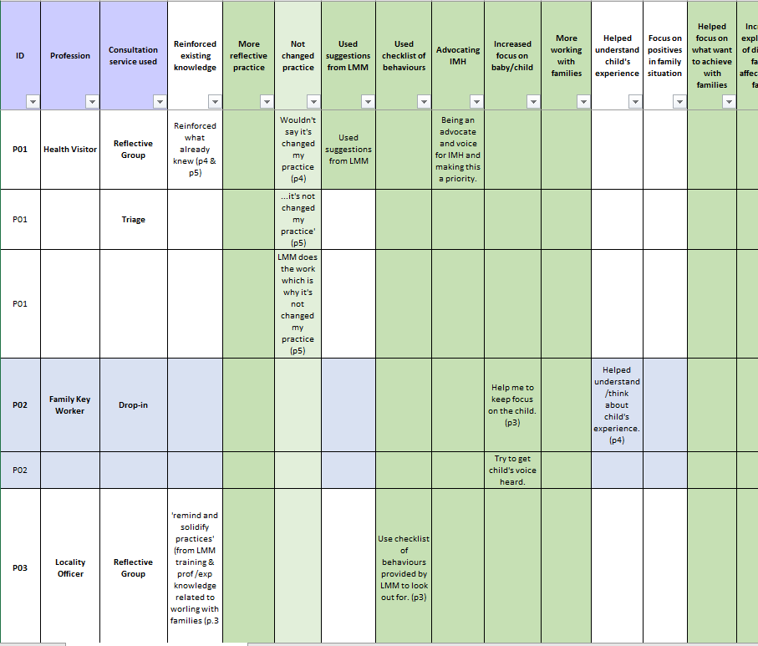

Appendix 9 – Snapshot of some of the headings that were printed off and consolidated into fewer themes

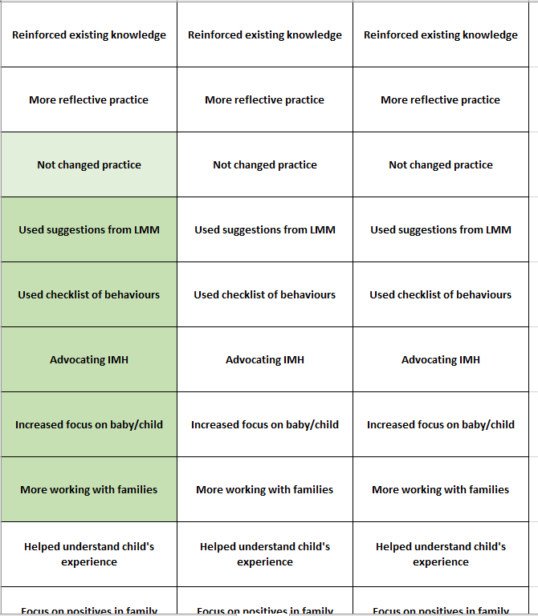

Appendix 10 – Consolidated themes transferred to Microsoft Excel

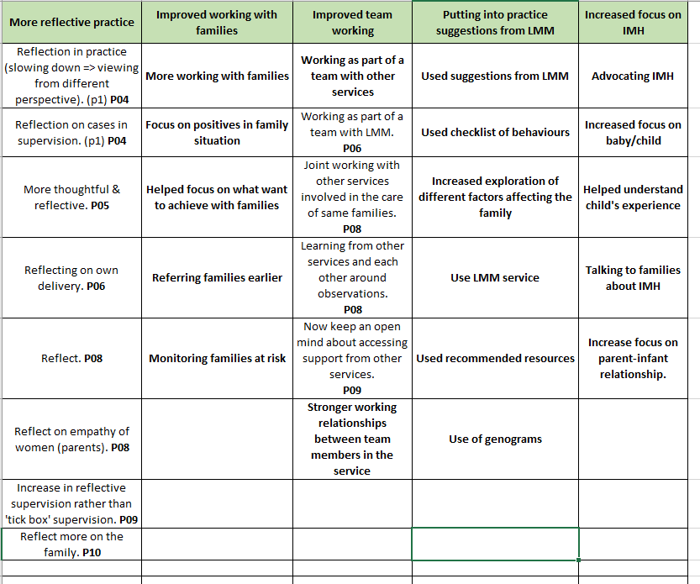

Appendix 11 – Different tabs created in Microsoft Excel for each development in themes

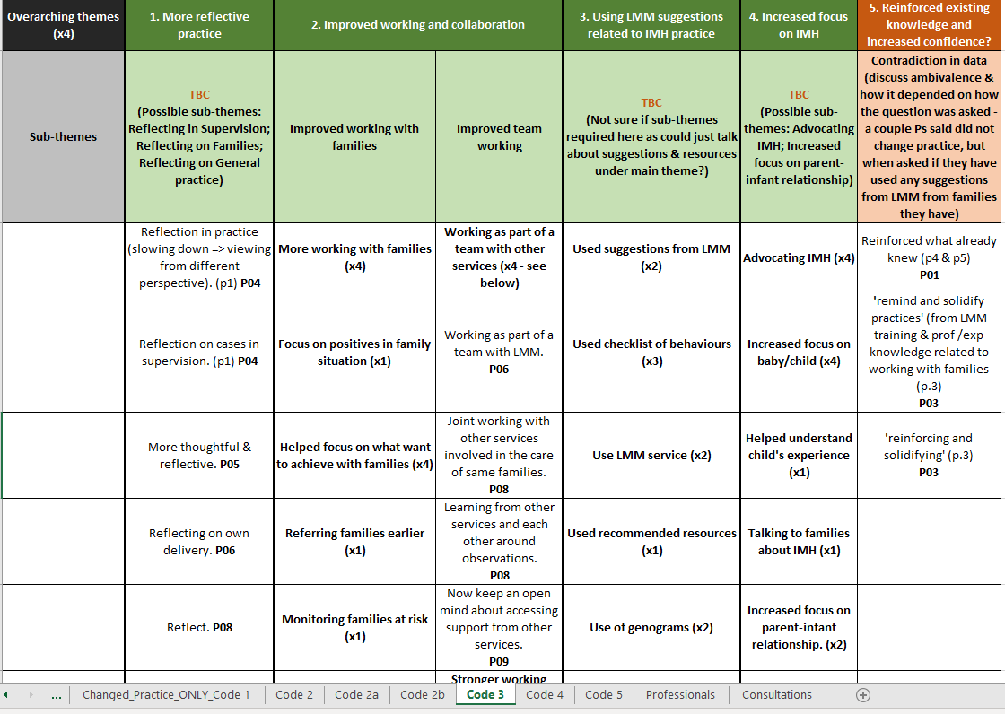

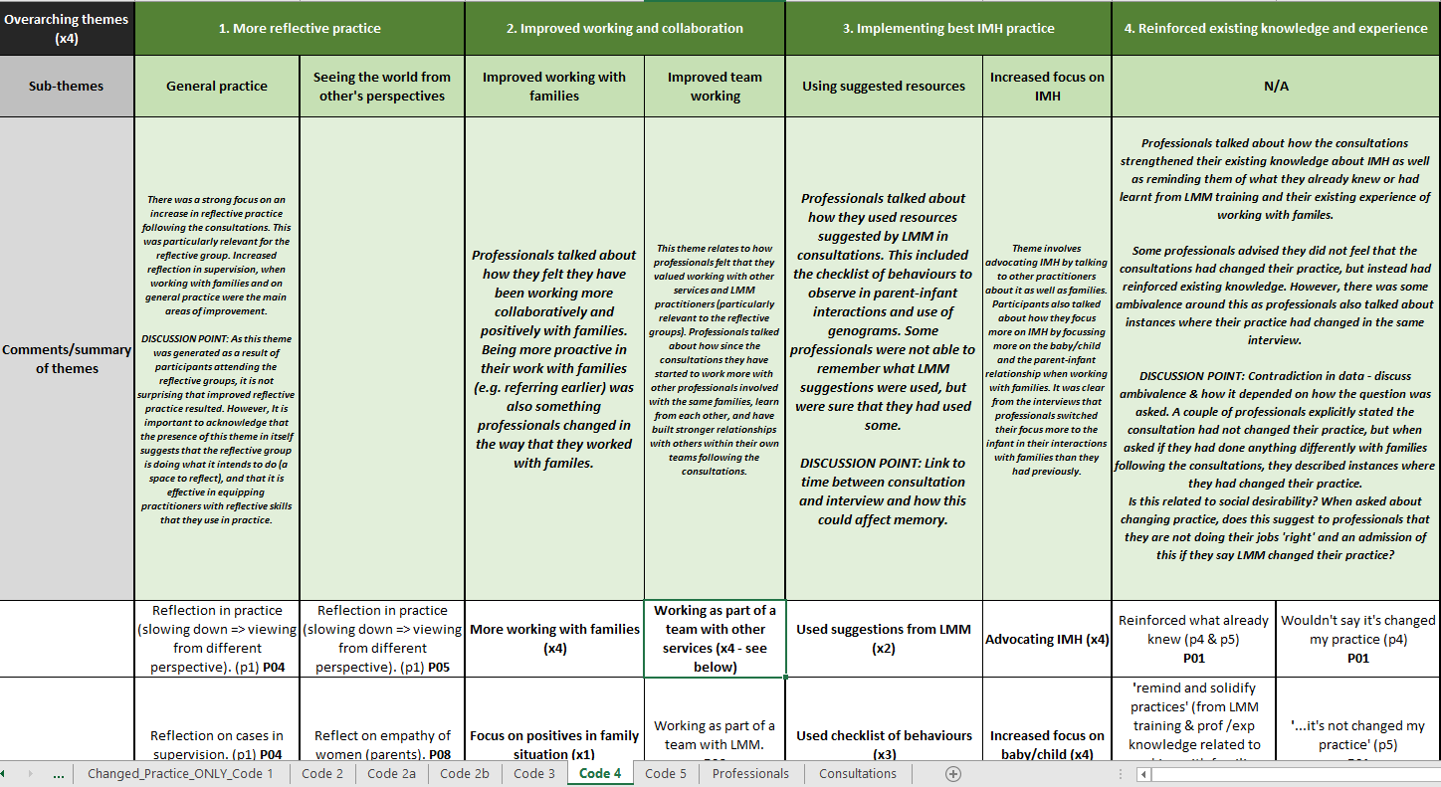

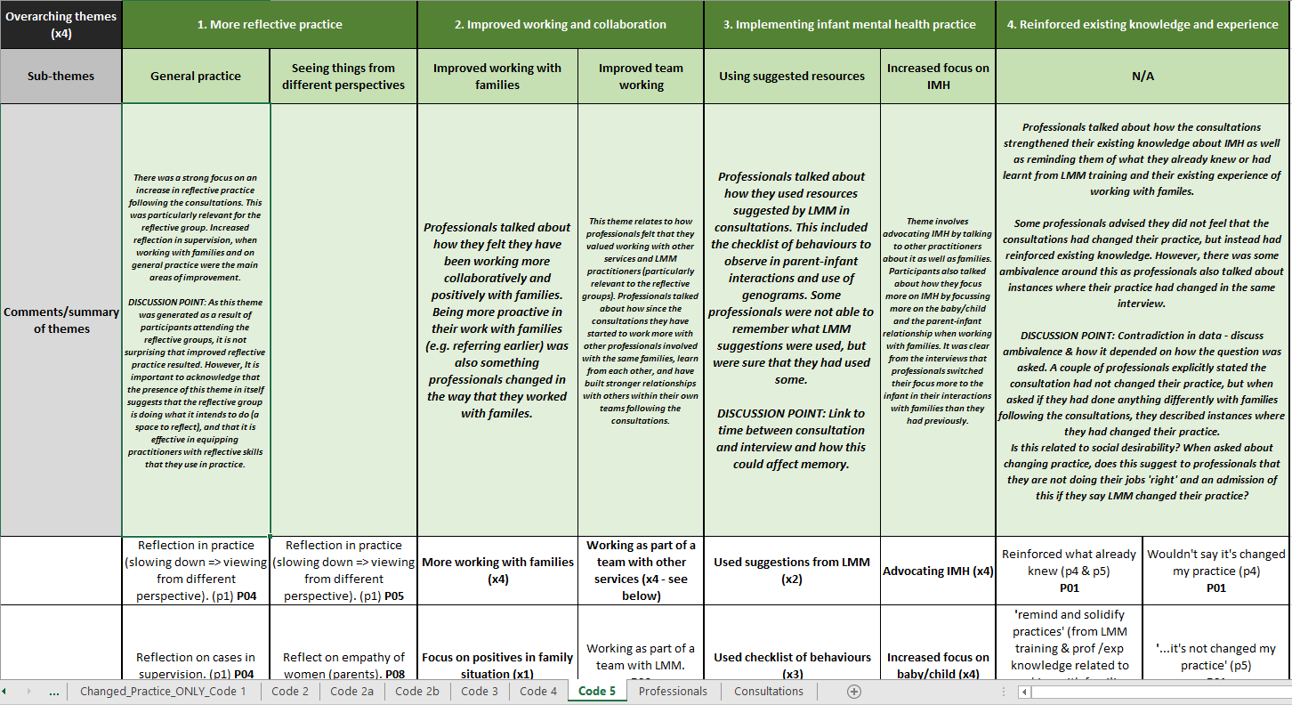

Appendix 12 – Checklist of behaviours to observe in parent-infant interactions

Observing Interactions

Watch the Intervention Carefully
- What sleep/wake state was the baby in?
- Was this interaction too much, too little or just right for this baby at this time?
- How would you describe the baby’s experience? If you were the baby how would you feel?
- Did the adult give space and time to encourage the baby’s initiative?
- Was there eye contact between them? Too much, too little or just right?
- Did the baby become overwhelmed? Was he able to look away and come back in his own time (rupture and repair)?
- How was the adult able to help the baby regulate his emotions?
- How did the baby respond to the touch? Notice if the parent kissed the baby and how the baby responded.
- What voice tones were used by the adult and baby? Was there reciprocity (turn taking)?
- What was the baby’s posture and muscle tone like?
- Were the mother and baby well positioned for play?
- What do you imagine the mother might be feeling?
- Check your observations against the attunement principals. How many apply?
- Can you pick one authentic attuned moment that you can build on?

Attunement Principals
Being attentive | - Looking interested  - Turning towards  - Friendly intonation and posture  - Giving time and space for other  - Wondering about what they are doing, thinking or feeling
Encouraging initiatives | - Waiting  - Listening actively  - Showing emotional warmth through intonation  - Naming positively what you see, hear, think and feel  - Naming what you are doing, hearing, thinking or feeling  - Looking for initatives
Receiving initiatives | - Showing that you have heard, noticed the other’s initiative  - Receiving initiative with friendly body language  - Returning eye contact, smiling, nodding in response  - Receiving what the other is saying or doing with words  - Repeating the other’s words or phrases

Antenatal and Postnatal Vulnerability Factor Checklist
Stresses that might affect relationships within a family

- Interactional or Parenting variables:
ANTENATAL
- Lack of sensitivity to baby’s movement and/or development in utero
- Negative affect openly shown to the unborn baby
- Negative attributions made towards unborn baby – even if ‘jokey’
- Lack of preparation during pregnancy
- Lacks knowledge of parenting and child development
- Quality of partner relationship undermined or unsupported
- Lack of interest in and/or empathy shown towards pregnancy and unborn

POSTNATAL
- Lack of sensitivity to infant’s cries or signals
- Negative affect openly shown towards child
- Lack of vocalisation towards infant
- Lack of eye-to-eye contact
- Negative attributions made towards child – even if ‘jokey’
- Lack of preparation during pregnancy
- Does not anticipate or encourage child’s development
- Physically punitive towards child
- Quality of partner relationship undermined or unsupported

- Biological and vulnerability in the infant:
ANTENATAL
- Chronic maternal stress during pregnancy
- Predicted very low birth weight
- Developmental concerns in utero
- Exposure to harmful substances in utero

POSTNATAL
- Chronic maternal stress during pregnancy
- Very lethargic/non-responsive
- Resists holding/hypersensitive to touch
- Very difficult temperament/extreme crying
- Regulatory/sensory integration disorder
- Low birth weight/prematurity
- Delivery complications
- Failure to thrive/feeding difficulties/malnutrition
- Exposure to harmful substances in utero
- Any suspected developmental delays

Appendix 13 – Self-appraisal form
Student ID number | 201290738
Title/topic | A service evaluation of Little Minds Matter Bradford consultation service: Exploring the influence on professional’s practice

UNIVERSITY OF LEEDS
Doctor of Clinical Psychology Programme
Service Evaluation Project: Self Appraisal

Section 1: Focus | 1 Strongly disagree | 2 Disagree | 3 Undecided | 4 Agree | 5 Strongly Agree
The SEP explores a relevant aspect of clinical practice |  |  |  |  | ☑
The SEP is placed within the wider theoretical literature relating to the topic |  |  |  |  | ☑
The SEP is placed within the wider theoretical literature relating to the research method |  |  |  |  | ☑
The SEP contains a critical appraisal of the literature discussed |  |  |  | ☑
The SEP was undertaken with clearly defined aims. |  |  |  |  | ☑
The project undertaken was of an appropriate size for a SEP project |  |  |  |  | ☑

Comments: I feel that this SEP was an appropriate size, explained the background of its importance and used critical analysis throughout (e.g. in relation to the research method and particularly in the discussion when results were placed in the context of existing literature).

Section 2: Research Method | 1 Strongly disagree | 2 Disagree | 3 Undecided | 4 Agree | 5 Strongly Agree
The design was appropriate for the aims of the SEP |  |  |  |  | ☑
Alternative designs were considered |  |  |  |  | ☑
Strengths and weaknesses of different designs were adequately discussed |  |  |  |  | ☑
The method chosen allowed for the collection of an adequate amount of relevant data |  |  |  |  | ☑
Efforts were taken to assess the reliability and validity of the data obtained |  |  |  | ☑
The researcher showed a good understanding of the method used |  |  |  |  | ☑

Comments: I feel the design was the right one for this SEP in terms of answering the research question and feel I have explained this adequately. I feel the amount of data collected was sufficient and that the qualitative method was explained and justified in the report.

Section 3: Implementation of Research Method | 1 Strongly disagree | 2 Disagree | 3 Undecided | 4 Agree | 5 Strongly Agree
The project was conducted with due consideration for ethics, in a sensitive and professional manner |  |  |  |  | ☑
Efforts were taken to identify and solve potential problems in data collection |  |  |  | ☑
An adequate amount of data was collected |  |  |  |  | ☑
The data analysis was appropriate for this project |  |  |  |  | ☑
The researcher showed an understanding of the method used in the analysis |  |  |  |  | ☑

Comments: Ethical approval was obtained, and the project conducted in line with the agreed procedure. Potential problems in recruitment were considered in the planning of the study (e.g. the fully recruited email should participants express an interest after the study was fully recruited). Sample size was considered and feel this was appropriate based on the literature and I feel I showed a good understanding of this method.

Section 4: Conclusions | 1 Strongly disagree | 2 Disagree | 3 Undecided | 4 Agree | 5 Strongly Agree
The conclusions were justified by the results |  |  |  |  | ☑
The findings of the project were placed in the wider context of relevant literature |  |  |  |  | ☑
The practical implications of the findings were discussed |  |  |  | ☑
The researcher shows an understanding of the limitations of the project, and ways in which it might have been improved |  |  |  |  | ☑

Comments: I feel the conclusions of the SEP were drawn from and justified by the results and placed in the context of wider literature. Practical implications related to the effect of the consultations were discussed as well as linking this to the use of the evaluation forms used in the service.

Section 5: Communication | 1 Strongly disagree | 2 Disagree | 3 Undecided | 4 Agree | 5 Strongly Agree
The project was written in a clear and accessible grammatical style |  |  |  |  | ☑
The project was well structured (e.g. with good use of headings, table and graphs) |  |  |  |  | ☑
The main points were presented in a logical and focused fashion |  |  |  |  | ☑
The results of the project were communicated to interested parties |  |  |  |  | ☑

Comments: Not exactly sure what this last point in this section refers to. I have ticked strongly agree because results were presented in the SEP presentation and I have communicated the results to the commissioner during the process of analysis. I feel the report was written in a logical fashion and was clear with accessible grammar.

Section 6: Overall mark

Marking the SEP is the responsibility of a member of staff at the university. In this section, however, you are asked to summarise your impressions of the quality of your work:

 | Fail | Refer with major amendments | Pass subject to correction of minor deficiencies | Pass subject to editorial or presentational corrections | Pass
 |  |  |  | ☑

Overall comments, including (where applicable) minor deficiencies, editorial or presentational corrections, or reasons for referral or failure:

Signed . 201290738 . . . . . . . . . . . . . . . . . . . . . . . . . . . . . Date . 10/11/2020. . . . . . .

Please include this self-appraisal form in the appendices of your SEP.
Thank you very much for your time

