Start for Life funding review – task for Workstreams.

At the request of the IC Leadership Group, we are to undertake a review of SFL impact and funding with the specific purpose of understanding the risks and requirements should funding cease as planned in March 2025.

We would like you to consider the following questions with your wider workstream colleagues. We will then use the information to inform the wider review.

Important – this questionnaire should not be considered as a business case or bid for funding. We know the value of the work that has taken place and that in an ideal world we would continue to provide all delivery and more. However, we need to be realistic. We need to set out the impact and outcomes and set out what must continue. We must concede what may have worked less well or can be managed differently and what risks there are in reducing the funded services. SfL has provided an opportunity to implement new ways of working and we want to define what should be reframed as “business as usual.” this could mean service redesign and consideration of funding, capacity and resources.

Workstream title or subgroup | Parent and Infant Relationship Service (PAIRS):  Part of the Infant/ Perinatal Mental Health Workstream
Allocated funding | PAIRS SERVICE 2023/4 2024/5  TOTAL
Funding breakdown | PAIRS SERVICE 2023/4 2024/5  PAIRS CAMHS  PAIRS 0-19s  Pathway up/support  TOTAL
Data – please include an accessible link to specific related data
Describe the SfL/FH funded service and activity delivered

The Parent-Infant Relationship Service (PAIRS) is an early intervention service which aims to support parents, carers and professionals to ensure Sheffield’s babies get the best start in life in order to thrive and be emotionally healthy. The service works with parents/ carers and their babies from conception to the child’s third birthday helping parents/carers better understand their baby’s needs and supporting them to provide sensitive, responsive care.
The PAIRS delivery model is set up across 4 domains:
- Promote good infant mental health (IMH) by sharing what is known about what babies need from their parents and caregivers in order to feel safe and secure and be mentally healthy.
- Training and consultation to a wide range of professionals and volunteers working with parents in the antenatal period and those with young babies to enhance their knowledge about IMH and what can be done to support healthy parent-infant relationships, and foster a common language and shared approach to giving babies the best start in life across the city.
- Supporting staff and volunteers providing universal offers, e.g., in Family Hub and/or community venues to provide activities which promote healthy parent-infant relationships and to spot emerging difficulties and refer for additional support where needed.
- Working with service users and professionals to co-produce a range of accessible resources to promote IMH and the importance of healthy parent infant relationships (PIR).
- Delivering public health promotion activities and events within Family Hubs and other community settings.

- Prevent the development of insecure and disorganised attachment in infants by reaching out to those parents/carers we know to be at greater risk of struggling to provide the sort of care their infants need with a proactive offer of support (proportionate universalism).
- Focus on population groups known to be at higher risk of developing difficulties in the parent-infant relationship. e.g, LAC and leaving care services, domestic abuse services, drug and alcohol services, edge of care, neonatal care, adult mental health services, etc. Support staff within these services to promote healthy parent-infant relationships.
- Identify families that are struggling with issues that can impact negatively on their capacity to provide sensitive, responsive care.
- Develop proactive offers of support over and above the universal offer for at risk groups e.g., targeted Mellow Bumps groups; Healthy Child Programme visits conducted by a PAIRS IMHP.

- Provide specialist support and intervention for those families where there is emerging parent-infant relationship (PIR) difficulties.
- A single point of referral leading to specialist assessment of the parent-infant relationship
- A pathway of support with PAIRS IMHPs sitting in the locality HV teams, supporting the identification of emerging difficulties in parent-infant relationships and making timely and appropriate onward referrals for those needing more targeted or specialist support.
- Evidence-based and practice-informed therapeutic interventions such as: Video Interaction Guidance (VIG), Circle of Security Parenting (COSP), Parent-infant psychotherapy, Dyadic art psychotherapy, Solihull and trauma-informed approaches, Baby massage, delivered in 1:1 or group settings.

- Championing babies’ needs across the system.
- Developing a joint strategic vision for babies’ emotional wellbeing across local health, social care and early years commissioning.
- Using expertise to help the local workforce to understand and support parent-infant relationships, to identify issues where they occur and take the appropriate action.

The Sheffield PAIRS Service is a multidisciplinary team, including psychologists, psychotherapists, Infant Mental Health Practitioners and a PIR Specialist Health Visitor, alongside managerial and administrative support. The service is jointly provided by CAMHS and the 0-19s Health Visiting service within Sheffield Children’s Hospital and offers evidence based therapeutic interventions to strengthen the parent infant relationship and promote secure attachment.
SfL funded expansion has, first and foremost, enabled delivery of a wider range of interventions to more families. Additionally, the team has become more multidisciplinary with a greater diversity of professional and therapeutic skills.
The development of a unique model of service delivery which straddles CAMHS and health visiting services has made it possible to establish a smooth pathway of support from universal health visiting provision to more targeted support provided by the PAIRS IMHPS and then, for families with the most complex needs, a specialist therapeutic offer provided by the PAIRS CAMHS clinicians.
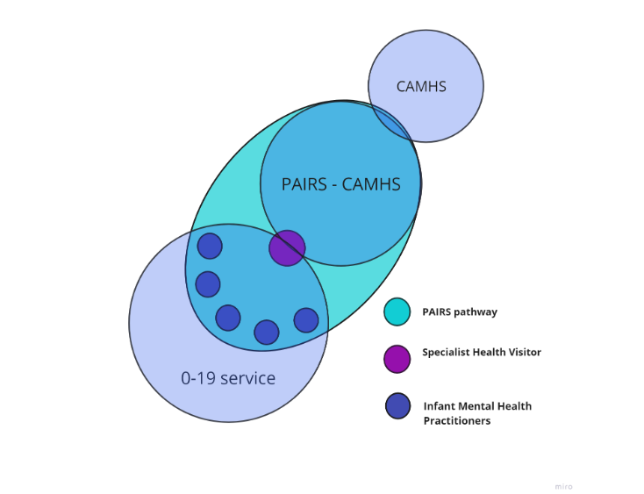
SfL funding has also enabled the PAIRS service to increase the volume of training, support and consultation it provides and deliver it to a broader range of professionals. This upskills those working directly with this service user population to provide ‘low level’ advice and support to promote health PIRs. It also enables frontline staff to identify emerging difficulties in the PIR and make appropriate onward referrals.
As a result of SfL funding, Sheffield now has a service that meets the Parent Infant Foundation’s criteria to be considered a specialist parent infant relationship team:
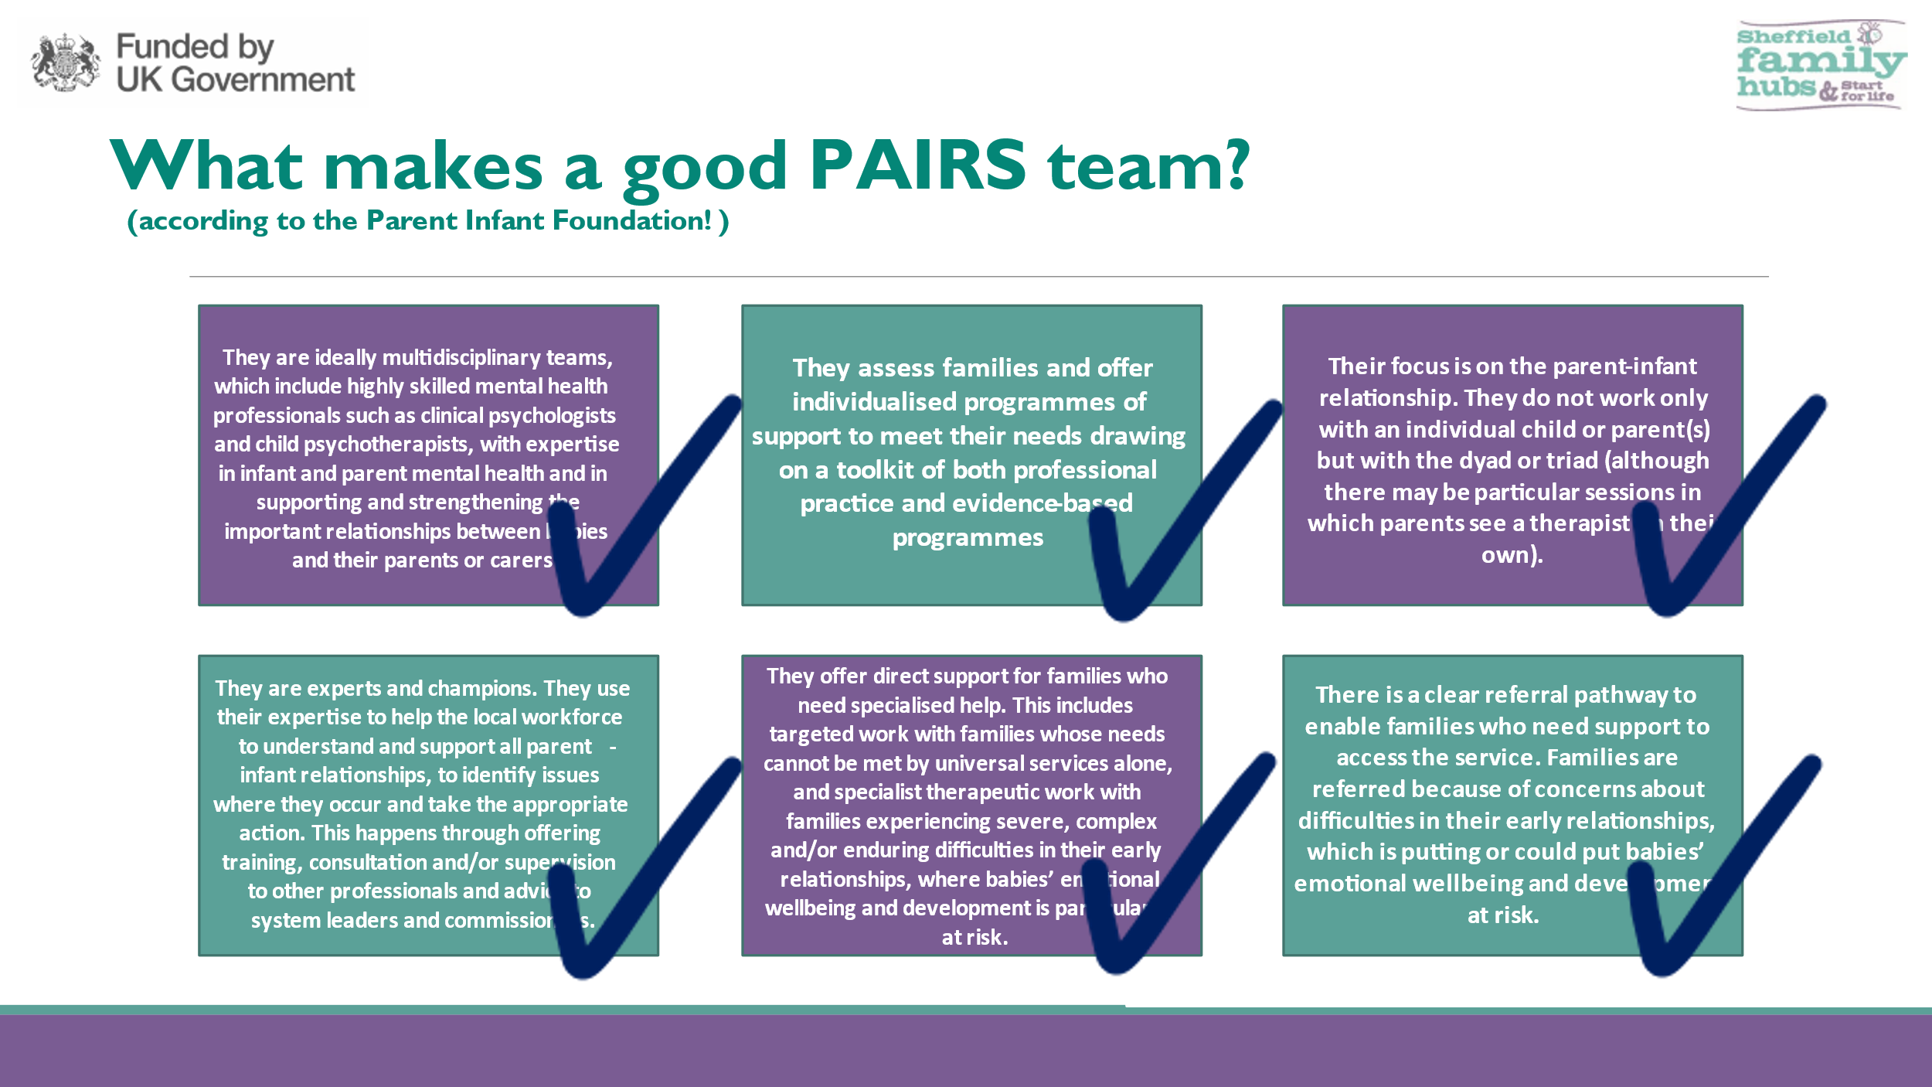

Please confirm the number of posts funded by SfL. Please include WTE grade and the employing organisation.
 | Perinatal and Parent-Infant Relationships Service | Band | WTE | Funding Source | Recurrently Funded?
CAMHS Team - in post prior to expansion | Service Lead, Consultant Psychologist
 | Senior Psychotherapist (Art)
CAMHS Team - additional resource post-expansion | Senior Clinical Specialist
 | Clinical Specialist
 | Infant Mental Health Practitioner (term time)
 | Assistant Psychologist
 | Service Delivery Manager
 | Business Support
0-19 IMH Team - additional resource post-expansion | Specialist IMH Health Visitor Lead
 | Infant Mental Health Practitioner Roles

Evidence base /rationale. This is particularly important where the evidence of impact is minimal. For example, where delivery has been recently established.

Please refer to the overarching IMH/PNMH workstream paper for a summary of the well-established evidence which makes the case for early intervention to promote secure parent infant relationships/ infant mental health. In addition to these compelling arguments, there are other local performance drivers that reinforce the importance of actively supporting healthy PIRs, such as the need to reduce pressure on waiting lists for CAMHS services and neurological assessment and the need to improve school readiness and close the attainment gap.

Early and accurate identification of whether children are experiencing PIR difficulties coupled with evidence-based interventions to address need where it is present is essential if we are to set children on the right path/developmental trajectory. Within the Sheffield Child and Adolescent Mental Health Service (CAMHS) there are large numbers of older children and adolescents with entrenched social, emotional and mental health difficulties that have originated from early attachment issues. There are also a group of children who may, wrongly, be waiting to be assessed for neurodevelopmental conditions when, in fact, their difficulties may be more accurately understood as a consequence of their experiences of early care. With the kind of early intervention and support to develop secure parent-infant attachments that a specialist infant mental health team can offer, these complex mental health problems and the potential for misdiagnosis can be avoided. Over a relatively short period of time, this would have the impact of reducing the number of referrals made for neurodevelopmental assessments and reducing CAMHS waiting lists.

Similarly, there is a need to improve school readiness and close the attainment gap. We know that healthy parent-infant relationships provide babies and toddlers with a sense of safety and security that is essential to enable them to play, explore, and learn. Babies and young children who receive sensitive, responsive care learn to regulate their emotions and control their impulses. Children who can control their emotions and behaviours are better equipped to settle into the classroom and learn. Better emotional regulation facilitates the acquisition of key skills such as being able to sit still, listen, wait and take turns, concentrate and manage frustration. In contrast, babies and toddlers who haven’t been taught to soothe themselves by being calmed and soothed by the adults in their lives are likely to become easily dysregulated and need more support to manage their emotions in the school setting. Promoting emotional co-regulation is at the heart of the specialised interventions offered by specialist parent-infant relationship teams. A child’s early relationships also shape their perceptions of themselves and others. Young children who have experienced sensitive caregiving are more confident in themselves and are able to form trusting relationships with others. As a result, they make and maintain friendships more easily and are more likely form positive relationships with adults when they start early education and throughout their school career.

Estimate of Population Need
In order to understand how many babies in Sheffield might need and benefit from PIR support, and at what levels, the Parent Infant Foundation estimate of need model has been applied to Sheffield population data and is provided below. Figures provided are based on the percentage of the birth population who are likely to develop disorganised or insecure attachment relationships which are linked to poorer outcomes across health, mental health, social skills, relationships, education and risk-taking behaviour. The model uses well established prevalence figures that:
- 55-60% of the population will have a secure attachment.
- 25-30% of the population will develop an insecure attachment style.
- 15% of the population will develop a disorganised attachment style.
These figures are then adjusted to reflect levels of deprivation and adversity within the local population as research evidence supports the notion that those in vulnerable groups have higher rates of disorganised attachment. Finally, it's estimated that for a range of reasons only third (25-33%) of those in need of PIR support will come to the attention of services before the age of 2 years and so separate figures are provided for need and demand.
(see: https://parentinfantfoundation.org.uk/tools/commissioning-toolkit/ for details of the assumptions underpinning the model).

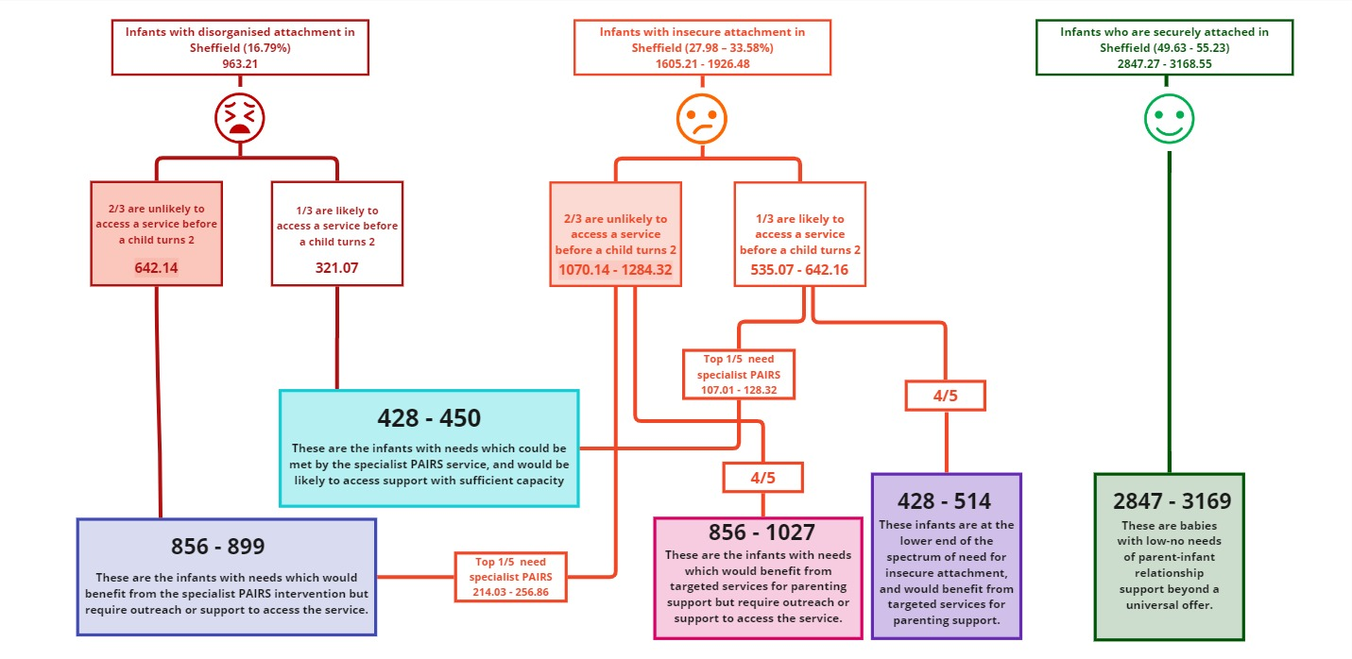

The numbers in the turquoise box represent the number of families in any given (yearly) cohort that would benefit from PAIRS support and would be likely to access it - the current demand for PAIRS support. The numbers in the blue box represents the number of families in any given (yearly) cohort that would benefit from PAIRS support but are unlikely to come to the attention of services - the unidentified need for PAIRS support but may nevertheless be in significant need and will likely include the most vulnerable, marginalised and at-risk babies.

The total number of families in any given cohort who could benefit from PAIRS support is the combined total of demand and unidentified need (blue and turquoise boxes combined): 1284 - 1349. It should be noted that these figures are for any given yearly cohort of births in Sheffield and the PAIRS service works across a 3.5 year age range from conception to 3rd birthday.

It takes time for new staff and referral pathways to become established and to function optimally/ at full capacity and the expansion of the PAIRS team is relatively recent with the team having only been at full establishment for 6 months. As a result, it is hard at this stage of implementation to be sure what the capacity of the PAIRS service is (in terms of how many families it is able to support per year as currently funded). Current estimates suggest that capacity will not meet the figure above of 428-450 suggesting that, over time, there would need to be an increase in resource in order for capacity to meet demand. By the end of the Start for Life Programme, we will have more reliable activity data to predict capacity and inform decisions about what level of funding would be required for a sustainable model of delivery. The service runs without a waiting list as babies’ brain development can’t be paused for 9 months whilst they and their parents/carers sit on a waiting list for support. There are critical windows of opportunity to intervene if we want to have the most impact. So, once we have more reliable capacity and demand data, decisions will need to be made about how much of the need (including families who are not currently coming to the attention of services) we want to address in order that we create sufficient capacity for the pathway to function effectively and not become overwhelmed by need that it is not resourced to meet.

Outcomes: What difference has the funded activity made? (evidence of impact on families/other services) What has changed as a result of the work? feedback/evaluation etc.
- Specialist Provision – We are now recognised by the Parent-Infant Foundation as one of 46 specialised Parent-Infant Teams in the UK. Investment has enabled us to grow from a small team with minimal capacity for direct clinical work to a multidisciplinary team providing a specialist, multi-intervention offer to the families of Sheffield.
- Workforce training - Alongside developing the specialist skills of our own workforce, we have been involved in training colleagues from 17 different organisations and now provide reflective supervision to the Family Intervention Service.
- Pathway development – Alongside our joint delivery model with 0-19 colleagues, we have actively engaged with citywide partners to raise awareness and establish referral pathways into a single point of access, developing new systems and processes to enable the provision of integrated, multi-agency support where families receive the support they need at the right time, delivered by a person with the appropriate knowledge and skills.
- Early Identification – Through the provision of training and consultation to those working with infants and families in Sheffield, we have been able to improve the early identification of infants and families who would benefit from specialist PAIRS support. The average age at referral this year is 5 months which represents a significant downwards shift. We have seen a large increase in the volume of referrals from health visitors, with this rising from 11 in 2022, to 24 in 2023, to 65 in the 4 months between Jan 2024 and April 2024. There has also been an increase in antenatal referral from midwifery services.
- Health Inequalities – We are striving to remove barriers to accessing care for the diverse population of Sheffield. Current figures suggest that 33% of families accessing the service identify as an ethnicity other than White British or White Irish (this compares to a figure of 20.9% of the Sheffield population who identify in this way). We are actively working with partner organisations to increase engagement with under-represented or minoritised groups, particularly those identifying as Asian or Asian British.
- Advocacy for the voice of the infant and PIRs – We are keen to share what we know about the importance of attuned PIRs with Sheffield families and those that work with them. We have created a range of accessible resources (digital and paper) and have attended promotional events to ‘spread the word’. We centre the voice of the baby and advocate for the importance of PIRs both within our service planning, and within the broad range of training and resources we have created and contributed to.
- National and Regional Advocacy – Aspects of the Sheffield PAIRS pathway model have been recognised as innovative by DHSC and the Parent Infant Foundation and the service lead has been asked to share expertise in PAIRS service planning and delivery to support other areas around how they shape their SfL offers.
- Service Evaluation – We recognise the importance of evidencing the impact of the service on the PIR and a range of child outcomes and are putting processes in place to support robust evaluation of the service offer and specific interventions. At this moment in the development of the service, it is too early to be able to evidence the full impact of the support that is being offered. This is partly due to there being insufficient outcome data at this time and partly as, by its very nature, some of the impact will take several years to emerge (e.g., improvements in measures of child development, school readiness; reduced need for emotional and behavioural support in school and in the home; reduced demand for neurodevelopmental assessment). Instead, please see below a case study to as an example of the service offer and the impact it can have.

Case Study
Initial referral to PAIRS made by the Health Visitor. The mother had taken time to express to her health visitor that she was struggling with her mental health and relationship with her infant, due to the fear that her children would be removed.
The initial phase of PAIRS intervention the mother and PAIRS clinician spent time talking about the circumstances surrounding the conception and difficulties in pregnancy, which led to immense guilt and fear of losing her baby throughout. The mother also experienced postnatal depression and spoke about how the recent concerns about her infant’s developmental delay had left her feeling further guilt and decline in her mental health. These sessions offered an opportunity for the mother to understand and work through the guilt she was feeling, identifying how this and her difficult pregnancy had impacted on her relationship with her infant. During these sessions the mother was also able to make important links between her own difficult childhood experiences and impact on her anxiety as a parent.
The mother agreed to Video Interactive Guidance intervention (VIG) with the aim to build confidence in her parenting and focus on how she was supporting her infant’s development. The mother and PAIRS clinician had identified that her negative thinking patterns were a barrier to her noticing any positive moments with her infant. Through VIG the mother was able to see her sensitive and attuned responses towards her infant and recognise, and believe, that she was supporting her infant’s development. Following VIG mum reported that she was making a conscious effort to notice positive interactions with her infant daily. The mother also reported significant improvements in her mental health. She felt more confident and happier in her relationship with her infant. The mother went on to access her own mental health support as well as signing up to various college courses due to identifying that she wanted to work on her own personal development.
Pre and Post outcome measures:
GAD-7: severe anxiety (20) to moderate anxiety (6)
PHQ-9: severe depression (25) to mild depression (5)
MORS-SF: warmth score of (11) increased to warmth score of (31) invasiveness score of (22) reduced to invasiveness score of (8)

What benefits have been realised because of the funded activity. Consider wider impacts on other services or families.
IMH Pathway development has resulted in an integrated and responsive system of services that is able to offer a coordinated approach to supporting healthy parent infant relationships. More of the babies whose development is a risk due to not getting the sensitive, responsive care they need are being identified and they are being identified at a younger age. There is now an expanded offer of support for families in need of support to better meet the social and emotional needs of their babies.
- To date 178 referrals for families have been received support from PAIRS since data for the service began being collected from November 2021.
- 63 of our referrals have come from Health Visiting, with a further 20 coming from Maternity Service.
- 52.5% of our families come from the most deprived areas of Sheffield (lowest 20% postcodes from the Index of Multiple Deprivation)
- 17 different teams within the city have benefitted from attending training held by the PAIRS service, increasing understanding about the importance of the parent infant relationship and the ability to identify those who might benefit from support. As well as awareness of the pathway offer.
- The average age of babies referred into the service has shifted from 1.6 years to 5 months, meaning that we are able to intervene earlier when we can be more effective.
The diagram below shows a visual representation of the progress made toward a more integrated, responsive infant mental health pathway.
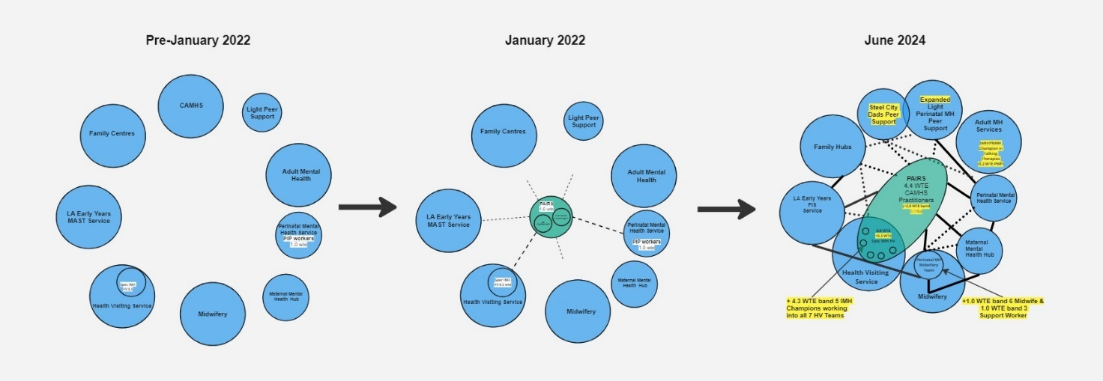

Can provision be mainstreamed within other budgets? If so, provide detail on conversations /agreements/ current status of negotiations etc, for example, any discussions with ICB (Integrated Care Board) or NHS colleagues

The implication of PAIRS provision being mainstreamed into other budgets (e.g., CAMHS or Health Visiting) would be to the detriment of other parts of the system and vice versa.

Presentations into CAMHS services being made up of moderate to severe complexity and the national drive for wait time standards to significantly reduce is a priority for commissioners and providers. The risk is extremely high therefore that the system regresses to the mean and the focus and funding is placed at the reactive end of the spectrum where risks are perceived* to be greatest. Therefore, whilst high waits are being experienced at the mainstream and specialist provision of CAMHS, the provision of early intervention and prevention for teams such as PAIRS need to be maintained through a clearly defined new budget and pathway provision linked to the NHS Long Term Plan and overall public health sustainability.

Similarly, within Health Visiting, commissioners and providers are focused on effective delivery of the Healthy Child Programme and meeting set standards for things like mandated visits and immunisations. Again, these pressures make it likely that resourcing a more targeted, specialist offer such as PAIRS would be seen as less of a priority than the core contracted offer.

Pressures within CAMHS, health visiting and other services such as in social care and adult mental health show no signs of reducing in the near future and babies can’t wait. If we want services that give babies the best start in life in Sheffield, then we need a clear strategy with an identified source of funding. The benefits of an effective IMH pathway are demonstrated across the system, in health, mental health, education and social care. It makes sense, therefore, for an IMH pathway to be funded collectively across multiple agencies.

*Figures from the most recent triennial analysis of serious case reviews (April 2014 – March 2017) found that 42% of 278 SCR reports that were available for review involved children under twelve months old, with a further 21% being aged one to five. These figures highlight the fact that owing to their complete dependence on adult care, lack of physical reserves, and limited ability to communicate, children under two years of age are especially vulnerable to harm as a result of abuse and neglect.
If funding is not found what is the impact? What will be left? Where is the risk? (where in the system would the risk be greatest?) what interdependencies exist?

- Service would revert to limited staffing and provision with Start for Life funded posts moving back into mainstream Community CAMHS.
- The established referral pathways would no longer be viable.
- The identified number of presenting disorganised and insecure attachment cases would not be seen in a timely manner.
- The number of disorganised and insecure attachment cases not presenting to statutory and non-statutory services would increase.
- The system would not retain offers of training or reflective supervision.
- Heavily reduced multiagency collaboration due to capacity constraints.
- Increase in unmet need.
- Reduced clinical outcomes.
- Reduced service user experience.
- Increased referrals into CAMHS and Adult MH services, 0-19 service, FIS/Parenting, Perinatal MH Midwifery team, HM&MHST, Edge of Care services, Substance Misuse, Domestic Abuse and more.
- Loss of a system supporting early identification of need.

If reduced funding were available, what compromises is acceptable? what are your priorities within this work. What are your recommendations?

- There is a substantial risk that loss to any part of the current funding model would significantly destabilise the pathway and its constituent parts.
- Any reduction or cost improvement would have a knock-on effect in terms of contract and employment legislation as well as staff wellbeing and role retention.
- Reduced funding would affect our ability to provide multidisciplinary working, which is an identified imperative factor for parent-infant service recognition.
- Our priorities are to retain current funding and work with Commissioners and Providers to consolidate PAIRS into a 5-year commissioned plan to incrementally increase the offer to a recommended percentage population of Sheffield’s birth rate.

Breakdown of estimated costs of recommended continued delivery
Total for current costing model:
Service | Cost | Funded by:
CAMHS PAIRS
0-19 PAIRS
PAIRS TOTAL

If funding were to continue, what would you retain? What would you Change? What would be your next steps?

In order to benchmark with national objectives and to retain and improve the Parent Infant Foundation’s recognition of the Sheffield PAIRS, funding would need to be maintained with a plan to incrementally increase over a 5-year period. With collaborative priorities in order to optimise the resource to the biggest need in the population and where can make most impact - improving lives and cost savings.

The service would look to instigate a service improvement programme and regularly review outcomes to ensure a flexible approach in relation to data analysis and performance across the system.

In order to support the clinical delivery, it is important to ensure that the administrative and operational functions are also factored in.

Breakdown of estimated costs of recommended retained/additional/changed delivery
Service | Cost | Funded by:
CAMHS PAIRS
0-19 PAIRS
PAIRS TOTAL

