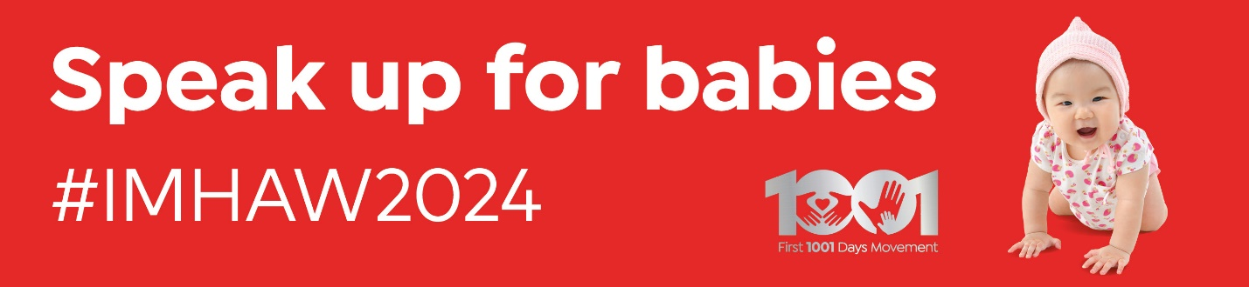

Hosting a MP visit - a guide

**Contents:**

* Introduction
* Which MP (or candidate) should I invite?
* When is good for MP visits?
* Who should attend?
* Social media and press
* Template email to invite your MP
* Example agenda

**Introduction**

This guide has been written to support parent-infant teams and other local services who are inviting their local MP or candidate to visit their service as part of the ‘Speak up for babies’ campaign for Infant Mental Health Awareness Week 2024.

Although MPs can read policy papers and reports on the importance of the first 1001 days and the parent-infant relationship, nothing beats hearing it first-hand from the experts: Professional experts trained to understand the signs of distress in babies, who can help families provide sensitive nurturing care, and experts with lived experience - parents and carers who can talk about the positive difference the support has made to their relationship and to their baby’s wellbeing.

If you have further queries after reading the guide, you can get additional advice from the team (Keith, Tam, Ben and Emma) - please email [BabyPM@parentinfantfoundation.org.uk](mailto:BabyPM@parentinfantfoundation.org.uk)

**Which MP (or candidate) should I invite?**

MPs will only usually visit a service that is in their own constituency. So before contacting the MP do check who is the right MP for your service. You can check by entering the postcode for the location into this checker: [here](https://members.parliament.uk/FindYourMP)

If your MP has announced they are not standing at the next general election, they could still visit. However, if it is likely that you will have a new MP after the election, or if the current MP has recently visited your service, it may be better to invite the parliamentary candidate from the other main party in your area.

Although it is not advisable to invite more than one candidate to visit at the same time, it is perfectly acceptable to switch to inviting a different candidate if you cannot get a response from the first MP you contact. It usually takes a week for emails to be replied to, and a follow-up phone call too. MPs have a small office team, and candidates may not have any paid staff, so do not be disheartened if you do not get a swift response.

**When is good for MP visits?**

Fridays are the best day usually for MP visits because MPs are in their constituencies rather than in parliament. If your MP suggests a different day, then it’s worth asking whether it is likely they could be called to vote at short notice. Obviously cancelling families at the last minute is not ideal, so although sometimes cancellations cannot be helped, organising visits for a Friday reduces the likelihood of a late cancellation. Allow two hours in total for the visit (see example agenda below).

**Who should attend?**

Normally the MP will come with just one staff member (or candidates may come alone). To ensure you build a good rapport, and are able to have a meaningful discussion, it is therefore best not to overcrowd the visit with too many people attending. In general, given there are also families and children, the best approach is to limit the number of staff attending and avoid attendees who do not have a clear role This will allow the MP adequate time to meet families and babies, to hear about their personal experiences.

The crucial attendees are:

* **A clinical lead:** The role of the clinical lead is to explain the sensitive and specialist work that teams do. The lead might explain what infant mental health means, and how they recognise the signs of distress in babies. The clinical lead can also explain the complexity of the work, and the severity of the trauma they are helping families address. This can be brought to life by talking through a case study, and explaining the range of interventions teams deploy. The clinical lead might bring this to life further by showing how VIG is used.
* **A parent or carer with lived experience:**  Nothing is more impactful than hearing from a parent or carer the difference support has made to them and their baby. This may be someone who has been through the service already and can therefore recall their struggles at the start of the work, and the positive difference the support made to their relationship with their baby.
* **A baby:** The participation of babies (and their parents or carers) is crucial! MPs love meeting babies and could either meet a family who has been through treatment and can talk about the experience or join in a group session. The clinical lead can explain that group sessions typically involve families with lower levels of need/complexity, but they are still supporting the parent-infant relationship. Also, that they are an important way for families to access support and a route to help with more complex issues. Providing you have already arranged permission in advance, photos can be taken for use on social media or sent to local media (see section below on this).
* **A national policy lead:** Ideally a policy lead from the Parent-Infant Foundation or from another First 1001 Days member charity will attend the visit, to discuss the wider policy context. The policy lead can liaise with the MP’s staff and discuss national policy developments like Start for Life, the government’s Major Conditions Strategy or Labour’s policy proposals.

Visits could also include a representative from another connected service (such as Midwifery Continuity of Care) or another member of the multi-disciplinary team. This could be a midwife, social worker or health visitor, to talk about how professionals work together to support the parent-infant relationship.

If your service is based in a children’s centre, family hub or other community centre, then the director of the centre might attend, to explain how local services are organised and funded. As there are different service models in different parts of the country and across the UK, you will need to adapt this according to your local context.

**Social media and press**

Please arrange for photos of the visit that can be used in the ‘Speak up for babies’ campaign, on social media and potentially by local/regional newspapers.

The ‘ideal’ shot list is as follows:

1. **Head and shoulder shot of the visiting MP holding a ‘Speak up for babies’ campaign board.** Our campaign team can bring along or post you a ‘Speak up for babies’ campaign board. The photo should be taken against a plain background. We will use these photos on the campaign website here: [politicians speaking up for babies](https://parentinfantfoundation.org.uk/1001-days/speak-up-for-babies/joined-the-campaign/)

2. **Photo of the MP meeting babies.** In advance of the MP visit, please get written permission from families who are willing for their babies to be in campaign photos. Your service/trust/centre’s communications team should have a pro forma consent form, to obtain parent/carer permission. This should cover whether families are happy for the photos to be used on social media (by your service, the campaign and the MP) and/or by local media (likely to be the local newspaper).

If you have permission to use photos with local media, then our campaign team can liaise with the MP’s office and your communications team in advance of the visit, to agree a press release.

The photos and the release will be sent to the local newspaper immediately after the visit, so the photographer needs to provide them immediately when the visit ends.

Below are two examples of good photos from recent MP visits that were used by local newspapers and on social media:

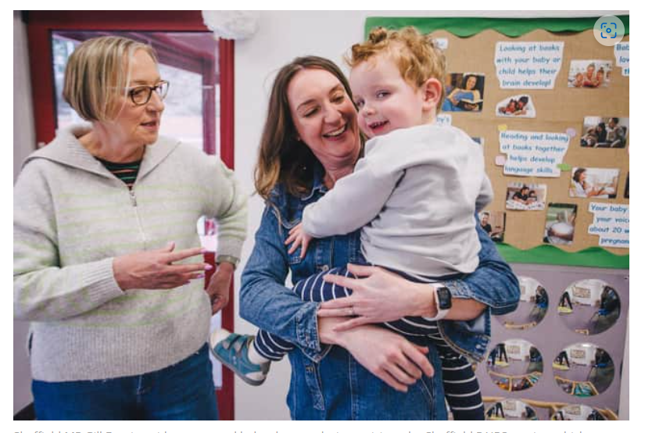

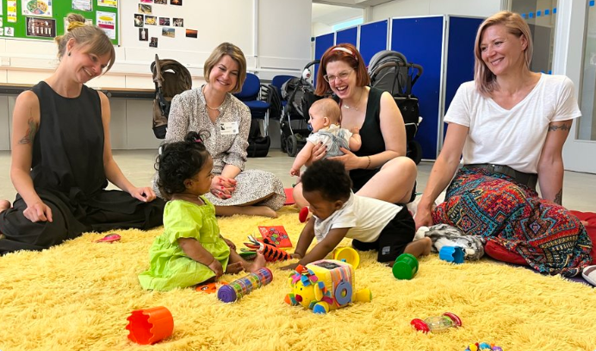

For social media, our IMHAW comms pack includes examples of tweets containing the Speak up for Babies key messages. Please tag the MP and @ParentInfantFdn and use the campaign hashtag #Speakupforbabies If you can please also post on LinkedIn and tag us: [Parent-Infant Foundation | LinkedIn](https://www.linkedin.com/company/parent-infantfoundation/)

For local media, we have a template press release that we can send to local media ahead of the visit, adding a quote from you and from the MP. If you let us know at least a week before the visit then we can liaise with the MP’s office to provide this to the local paper. Please contact [BabyPM@parentinfantfoundation.org.uk](mailto:BabyPM@parentinfantfoundation.org.uk)

To allow the MP visit to be focused on the conversations with the clinical lead and families, we do not suggest inviting any journalists to attend the visit. Instead, we will send the local paper photos immediately following the visit (ideally the photo of the MP meeting babies).

**Template email to invite your MP**

Please feel free to copy us into your invite (or else forward to our campaign inbox: [BabyPM@parentinfantfoundation.org.uk](mailto:BabyPM@parentinfantfoundation.org.uk))

**Email Subject:** Would you like to visit our service and speak up for babies?

Dear *MP NAME*

I am the clinical lead for *team/service name, address*, supporting babies and their families to build strong relationships and thrive. I’m writing to invite you to visit and meet some of our families, as part of Infant Mental Health Awareness Week (10th to 16th June).

This year’s theme is ‘Speak up for babies’. Too often babies are overlooked but we hope you agree it’s important we do not overlook their needs.

At least one in ten babies in the UK is living in fear and distress. These babies are scared and overwhelmed by disrupted relationships with their parent or main carer. Without help, these babies are more likely to develop mental health conditions in childhood. This is what our work focuses on, and we would love to explain it to you and arrange for you to visit some of the families we support.

Two-hours would be an ideal time frame for a visit. This will allow time for you our team to explain the more sensitive work we do, and also for you to meet with families and babies who have benefited from the service.

We would arrange for a photographer to capture your visit so we have images to share with your constituents, to help raise awareness.

We are happy to work around your diary but hoped you might be able to visit during June, to coincide with the wider awareness campaign. The Parent-Infant Foundation team who run Infant Mental Health Awareness Week can also support with local media (if desired) and further information about the national campaign.

I look forward to hearing back from you.

Best wishes

NAME/PHONE

**Example agenda**

DATE:

TIME:

VENUE:

**Attendees** (and contact numbers/email)

Xxx

Yyyy

zzzz

**Timings**

**10.00** Arrival. *MP* to be greeted at the entrance by xxx

**10.10** Room 1: Briefing on the local service:

Clinical lead gives an overview of *team name*’s work. This will provide an opportunity to discuss in a confidential setting some of the sensitive work that happens with high needs families – talk through case study or show example of VIG. Also (depending on attendees) centre director/manager explains origins of service, funding and future plans. Or colleague explains how parent-infant team interfaces with other services (e.g. Midwifery Continuity of care/health visiting service or social care).

**10:40** Room 2:MPjoins a session to meet babies and parents. The session will be run by *name*. This is an opportunity for parents to talk with *MP* about their experiences.

A photographer will be present but will not stay for the whole session. We will ask families for prior permission for photography/video.

**11.25 to 11.55** Back to Room 1: Tea/coffee and policy discussion. National policy lead explains Speak up for babies campaign and national policy context. Photo of MP with Speak up for babies campaign board.

An opportunity for *MP* to ask questions about local and national policy and offer reflections.

**Midday MP departs** (photos and pre-approved press release sent to local media)

