Peer learning forum - 3rd November
Systems/ service mapping and pathways
This forum looked at service mapping and the development of referral pathways. These activities were on the agenda for some emerging teams on the call. Others were here to share their own experience. We looked at a few mapping and pathway documents during the call and discussed.
1. To kick us off we shared the Foundations recent work on Service Mapping in Wales.
Discussion points:
What model to use to describe the different levels of service. I.e. whether to use the language of different tiers e.g. universal, targeted, specialised, risk focused. This reflects the current model of care. ‘escalator model’ of stepped care, where families are stepped up through increasing levels of intensity.
Risk focused
Specialised
Targeted Family journey
Universal
However a recommendation has been made int the report to replace the escalator model of stepped care with the THRIVE framework, which has been developed by the Anna Freud Centre. The Thrive model is a more holistic model whereby high-quality parent-infant relationship assessment is available at the front door of services and a parent/infant dyad can access the treatment they need from the start.
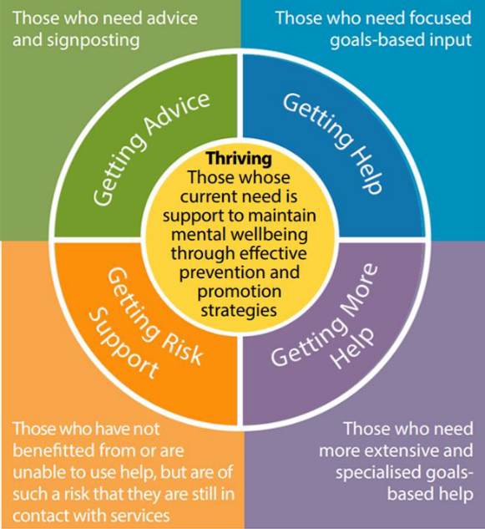
https://www.annafreud.org/mental-health-professionals/thrive-framework/

2. We then looked the draft of the Northwest pathway draft. This is a newly developed care pathway parents and infants under 5.
Other examples under development:
- Self-referral pathways being developed by Bradford – which will include an easy read leaflet

- Healthy Little Minds in Nottingham – developing self-referral pathways – which includes an idea of a “containing call” for self-referrals.
We are looking forward to seeing these once they are completed.
We have developed a new category in our resources library for teams and will be uploading all examples to here for reference.

