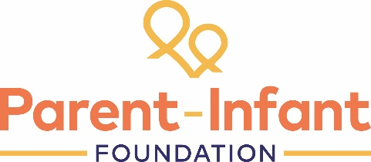
Peer-to-Peer Learning:
Discussion notes

Our thanks to members of the Parent-Infant Teams Network for sharing their experience and learning about this topic.

This topic came about because of an interest in this area from emerging teams who have been asked to develop a parent-infant service within an existing CAMHS team.

We opened up by hearing from a couple of team who had been running parent-infant teams as part of CAMHS for some time.
- Norfolk: Dite Felekki (Clinical lead)
This service has run for 9 years. It was initially commissioned as part of wider consortium and now is commissioned directly by the CCG as part of a block contract, which has a separate contract for under4’s provision.. The team is co-located with CAMHS but covers wider geographical area.
Team composition: 4 x FTE practitioners
It is commissioned as a tier 2 provider which does present some challenges. They would like to bring it in line with CAHMS.
Key challenges:
- Not seeing enough referrals for under 2’s
Most referrals are for children between 2 and 4 with fewer referrals for under 2’s
They take a lot of requests for support for pre-school 3-4 year olds with a diagnosis of PTSD – and these are typically referred to CAHMS practitioners for trauma therapy. This has been negotiated with CAHMS as they are commissioned as an attachment/ parent-infant relationship services.
Tricky area as CAMHS colleagues are often not confident to work with children under 6.
- Commissioners need to understand what they are commissioning
Need different skills set for all of below which need to be part of an under 5’s service:
- Pre-school – PTSD
- Parent-infant complex attachment service
- Parenting service

These often get conflated.
- Pulled in to fill the gaps in CAMHS because of long waiting lists and recruitment and retention issues in CAMHS and P-I team seen to ‘have capacity’. This can be worrying.
- Enfield – Carol Levine (clinical lead)
This service has been running for eight years. Enfield is one of London boroughs and one of first PIP’s funded by PIP Uk.
Very small service 1.1 FTE. CCG and health visitor funded, Currently a 0-2’s service within CAMHS, but now trying to develop into a 0-5 service.
The benefits of being just 0-2 is that they are very separate from CAMHS and have separate pathways and systems.
However, funding is insecure, hence the aim to develop the current 0-2 service within a 0-5 service and secure funding for the 0-2 within this.
Q – Does it include pregnancy? If so then connection with midwives.

Discussion:
- Discussion about one to one and diadic work in under 5’s.
Toddlers/ early years may often present with behaviour issues, which may indicate underlying PTSD. They should have the right to have individual as well as diadic work. Diadic work is not always the right option when PTSD is present. Assessment is key and important not to miss PTSD needs when looking through a relationship lens
- NDD neuro-developmental – suggestion that this can all be dealt with under one roof in a more holistic service – need to include paediatrics in multi-disciplinary team
- Discussion about the importance of educating commissioners about the differing needs of infants – and the value of case studies being included in proposals to illustrate these issues to commissioners.

The final discussion lead to a request to share examples of system mapping exercises and referral pathways and to have a follow up peer learning forum about this topic

Next peer support call
Date: Wed 3rd November 2021 1-2.30pm

Topic: System mapping and pathways

